Product Installation and Upgrade Guide v4.1.0.0

Contents
1 Document Control 6
1.1 Author 6
1.2 Document Summary 6
1.3 Document History 6
1.4 Reference documents 6
1.5 Distribution 6
1.6 Quality Assurance 7
2 Introduction 8
2.1 Purpose 8
2.2 Products Covered by this Guide 8
2.3 Order in which to Install/Upgrade Products 9
2.4 Pre-Requisites to Installation/Upgrade 11
3 Network Manager 15
3.1 Installation of the Network Manager Software files 15
3.2 Highways Owner Account 16
3.2.1 Before you start: 16
3.2.2 Creation of a Highways Owner 16
3.3 Network Manager Server Install/Upgrade 18
3.3.1 Before you Start 18
3.3.2 Typical problems that you may encounter 18
3.3.3 Creation of the Exor_Core User and Objects 18
3.3.4 Install of Network manager 19
3.3.5 Upgrade of Network Manager 19
3.3.6 Post Install/Upgrade Tasks 20
3.3.7 Additional Configuration 23
3.3.8 EXOR_JPG.JAR 24
3.3.9 Spatial Configuration 24
4 Maintenance Manager 25
4.1 Implementation of the Maintenance Manager Software files 25
4.2 Maintenance Manager Server Install/Upgrade 26
4.2.1 Before you Start 26
4.2.2 Typical problems that you may encounter 26
4.2.3 Install of Maintenance Manager 26
4.2.4 Upgrade of Maintenance Manager 27
4.2.5 Mandatory Configuration 28
4.2.6 Additional Configuration 28
4.2.7 Spatial Configuration 28
5 Enquiry Manager 29
5.1 Implementation of the Enquiry Manager Software files 29
5.2 Enquiry Manager Server Install/Upgrade 30
5.2.1 Before you Start 30
5.2.2 Typical problems that you may encounter 30
5.2.3 Install of Enquiry Manager 30
5.2.4 Upgrade of Enquiry Manager 31
5.2.5 Mandatory Configuration 32
5.2.6 Additional Configuration 32
5.2.7 Spatial Configuration 32
6 Street Gazetteer Manager 33
6.1 Implementation of the Street Gazetteer Manager Software files 33
6.2 Street Gazetteer Manager Server Install/Upgrade 34
6.2.1 Before you Start 34
6.2.2 Typical problems that you may encounter 34
6.2.3 Install of Street Gazetteer manager 34
6.2.4 Upgrade of Street Gazetteer Manager 35
6.2.5 Mandatory Configuration 36
7 TMA Manager 36
7.1 Implementation of the TMA Manager Software files 36
7.2 TMA Manager Server Install/Upgrade 36
7.2.1 Before you Start 36
7.2.2 Typical problems that you may encounter 36
7.2.3 Install of TMA Manager 36
7.2.4 Upgrade of TMA Manager 36
7.2.5 Mandatory Configuration 36
7.2.6 Web Service Install\Upgrade 36
ApEx 36
8 TMA API 36
8.1 Implementation of the TMA API Software files 36
8.2 TMA API Server Upgrade 36
8.2.1 Before you Start 36
8.2.2 Typical problems that you may encounter 36
8.3 TMA External Notice API Implementation 36
8.3.1 Deployment of API Software Files 36
8.3.2 API Server Component Install/Upgrade 36
9 Streetworks Manager 36
9.1 Implementation of the Streetworks Manager Software files 36
9.2 Streetworks Manager Server Install/Upgrade 36
9.2.1 Before you Start 36
9.2.2 Typical problems that you may encounter 36
9.2.3 Install of Streetworks Manager 36
9.2.4 Upgrade of Streetworks Manager 36
9.2.5 Mandatory Configuration 36
9.2.6 Additional Configuration 36
9.2.7 Spatial Configuration 36
10 Asset Valuation Manager 36
10.1 Implementation of the Asset Valuation Manager Software files 36
10.2 Asset Valuation Manager Server Install/Upgrade 36
10.2.1 Before you Start 36
10.2.2 Typical problems that you may encounter 36
10.2.3 Install of Asset Valuation Manager 36
10.2.4 Upgrade of Asset Valuation Manager 36
10.2.5 Mandatory Configuration 36
10.2.6 Additional Configuration 36
11 Accidents Manager 36
11.1 Implementation of the Accidents Manager Software files 36
11.2 Accidents Manager Server Install/Upgrade 36
11.2.1 Before you Start 36
11.2.2 Typical problems that you may encounter 36
11.2.3 Install of Accidents Manager 36
11.2.4 Upgrade of Accidents Manager 36
11.2.5 Mandatory Configuration 36
11.2.6 Additional Configuration 36
12 Public Rights Of Way Manager 36
12.1 Implementation of the Public Rights Of Way Manager Software files 36
12.2 Public Rights Of Way Manager Server Install/Upgrade 36
12.2.1 Before you Start 36
12.2.2 Typical problems that you may encounter 36
12.2.3 Install of Public Rights Of Way Manager 36
12.2.4 Upgrade of Public Rights Of Way Manager 36
12.2.5 Mandatory Configuration 36
12.2.6 Additional Configuration 36
13 Street Lighting Manager 36
13.1 Implementation of the Street Lighting Manager Software files 36
13.2 Street Lighting Manager Server Install/Upgrade 36
13.2.1 Before you Start 36
13.2.2 Typical problems that you may encounter 36
13.2.3 Install of Street Lighting Manager 36
13.2.4 Upgrade of Street Lighting Manager 36
13.2.5 Mandatory Configuration 36
13.2.6 Additional Configuration 36
14 Schemes Manager 36
14.1 Implementation of the Schemes Manager Software files 36
14.2 Schemes Manager Server Install/Upgrade 36
14.2.1 Before you Start 36
14.2.2 Typical problems that you may encounter 36
14.2.3 Install of Schemes Manager 36
14.2.4 Upgrade of Schemes Manager 36
14.2.5 Mandatory Configuration 36
14.2.6 Additional Configuration 36
15 Structures Manager 36
15.1 Implementation of the Structures Manager Software files 36
15.2 Structures Manager Server Install/Upgrade 36
15.2.1 Before you Start 36
15.2.2 Typical problems that you may encounter 36
15.2.3 Install of Structures Manager 36
15.2.4 Upgrade of Structures Manager 36
15.2.5 Mandatory Configuration 36
15.2.6 Additional Configuration 36
16 Traffic Interface Manager 36
16.1 Implementation of the Traffic Interface Manager Software files 36
16.2 Traffic Interface Manager Server Install/Upgrade 36
16.2.1 Before you Start 36
16.2.2 Typical problems that you may encounter 36
16.2.3 Install of Traffic Interface Manager 36
16.2.4 Upgrade of Traffic Interface Manager 36
16.2.5 Mandatory Configuration 36
16.2.6 Additional Configuration 36
17 UKPMS 36
17.1 Implementation of the UKPMS Software files 36
17.2 UKPMS Server Install/Upgrade 36
17.2.1 Before you Start 36
17.2.2 Typical problems that you may encounter 36
17.2.3 Install of UKPMS 36
17.2.4 Upgrade of UKPMS 36
17.2.5 Mandatory Configuration 36
17.2.6 Additional Configuration 36
18 Main Roads Western Australia 36
18.1 Implementation of the Main Roads Western Australia Software files 36
18.2 Main Roads Western Australia Server Upgrade 36
18.2.1 Before you Start 36
18.2.2 Typical problems that you may encounter 36
18.2.3 Install of Main Roads Western Australia 36
18.2.4 Upgrade of Main Roads Western Australia 36
18.2.5 Mandatory Configuration 36
18.2.6 Additional Configuration 36
19 Highways Agency Interface 36
19.1 Implementation of the Highways Agency Interface Software files 36
19.2 Highways Agency Interface Server Install/Upgrade 36
19.2.1 Before you Start 36
19.2.2 Typical problems that you may encounter 36
19.2.3 Install of Highways Agency Interface 36
19.2.4 Upgrade of Highways Agency Interface 36
19.2.5 Mandatory Configuration 36
19.2.6 Additional Configuration 36
20 Mapserver 36
20.1 Implementation of the Mapserver Software files 36
20.2 Mapserver Implementation 36
20.2.1 Deployment of Mapserver Software Files 36
20.2.2 Mapserver Component Install 36

- Document Control
  - Author
Exor Development
  - Document Summary
This document covers steps involved in installing/upgrading the components for:
- Network Manager
- Maintenance Manager
- Enquiry Manager
- Street Gazetteer Manager
- TMA Manager
- TMA API
- Streetworks Manager
- Accident Manager
- Asset Valuation Manager
- Traffic Interface Manager
- Public Rights Of Way Manager
- Street Lighting Manager
- Structures Manager
- Schemes Manager
- UKPMS
- Main Roads Western Australia
- Highways Agency Interface

  - Document History

Document History
Revision | Date | By | Description
1.0 | 05-Oct-2009 | Exor Development | First Edition

  - Reference documents
None

  - Distribution
Exor Customers, Partners and Staff

  - Quality Assurance
Document Details
File | Prepared By
0000.doc | Exor Development
Document Name | Reviewed By
Product Installation and Upgrade Guide v4.1.0.0 | Colin Stewart
Version | Approved for issue by
1.0 | Colin Stewart
Date of Issue | Support Manager
30-Oct-2009 | Graham Anns

- Introduction
  - Purpose
This guide covers steps involved in installing or upgrading the components for:
- Network Manager
- Maintenance Manager
- Enquiry Manager
- Street Gazetteer Manager
- TMA Manager
- TMA API
- Streetworks Manager
- Accident Manager
- Asset Valuation Manager
- Traffic Interface Manager
- Public Rights Of Way Manager
- Street Lighting Manager
- Structures Manager
- Schemes Manager
- UKPMS
- Main Roads Western Australia
- Highways Agency Interface

Each product install/upgrade is split into two distinct stages,

- Stage 1 – Implementation of the Software files
- Stage 2 – Install/Upgrade of the Server

  - Products Covered by this Guide
Table 1 lists the relevant products that are covered by this guide.

Product | Install | Upgrade From 4.0.5.4 | Upgrade From 4.0.5.3 | Upgrade From 4.0.5.2
Network Manager |  |  |  | 
Maintenance Manager |  | ✗ | ✗ | 
Enquiry Manager |  | ✗ | ✗ | 
Street Gazetteer Manager |  | ✗ | ✗ | 
TMA Manager |  | ✗ | ✗ | 
TMA API |  | ✗ | ✗ | 
Street Works Manager |  | ✗ | ✗ | 
Asset Valuation Manager |  | ✗ | ✗ | 
Accidents Manager |  | ✗ | ✗ | 
Public Rights Of Way Manager |  | ✗ | ✗ | 
Street Lighting Manager |  | ✗ | ✗ | 
Schemes Manager |  | ✗ |  | 
Structures Manager |  | ✗ | ✗ | 
Traffic Interface Manager |  |  | ✗ | ✗
UKPMS |  | ✗ | ✗ | 
Main Roads Western Australia |  | ✗ | ✗ | 
Highways Agency Interface |  | ✗ | ✗ | 
Table 1: List of products covered by this guide

  - Order in which to Install/Upgrade Products
Table 2 lists the order in which to install/upgrade the products in this release.

Product to Install/Upgrade | Order to Install/Upgrade
Network Manager | 1
Maintenance Manager | 2
Enquiry Manager | 3
Street Gazetteer Manager | 4
TMA Manager | 5
TMA API | 6
Street Works Manager | 7
Asset Valuation Manager | 8
Accidents Manager | 9
Public Rights Of Way Manager | 10
Street Lighting Manager | 11
Schemes Manager | 12
Structures Manager | 13
Traffic Interface Manager | 14
Main Roads Western Australia | 15
UKPMS | 16
Highways Agency Interface | 17
Table 2: Order in which to install/upgrade products

  - Pre-Requisites to Installation/Upgrade
It is assumed that the audience of this document understand the configuration of the servers being installed/upgraded and are sufficiently proficient with SQL*Plus. It is also assumed that the terminology used in this document is understood by the reader.

NB. The instructions for installation of the software describes the installation of all the software into a single area (usually referred to as the ‘Client’). The instructions for upgrading the Server (your Highways schema) assume you have access to the database from the ‘Client’.

Your configuration and server access may differ from this; the InstallShield can still be used for installation. For example, you may have to install the Client software on the Application Server and the Server software on the Database Server for reasons of database access availablilty from the Application Server.

If in any doubt please contact support@exorcorp.com.

Before attempting to upgrade, you should ensure that;

- the appropriate software components are installed and are compatible with the exor certification matrix. The certification matrix can be downloaded from the Client area of the exor website.

- all users are disconnected from the system

- the highways listener processes are not running

- a database export of the owner of Highways owner has been taken.

- You MUST copy the current <exor_base> directory and sub-directory structure and contents to a new area (e.g. <exor_base4050>). This ensures that a copy is available for backup or reference purposes should any issues arise during the installation.
The installation can then continue into a new area (e.g. <exor_install4051>) which should then be copied onto the <exor_base>.

For Example:
….copy the current <exor_base> directory and sub-directory structure and contents to a new area (e.g. <exor_base4050>)

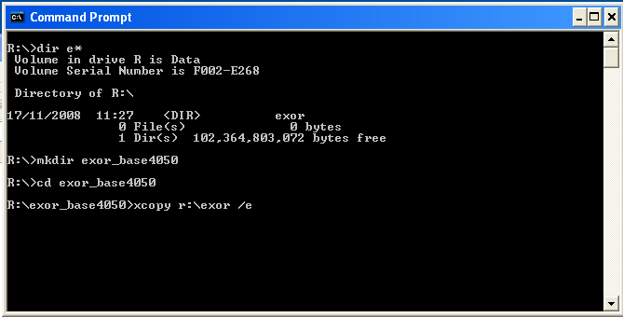

… The installation can then continue into a new area (e.g. <exor_install4051>)

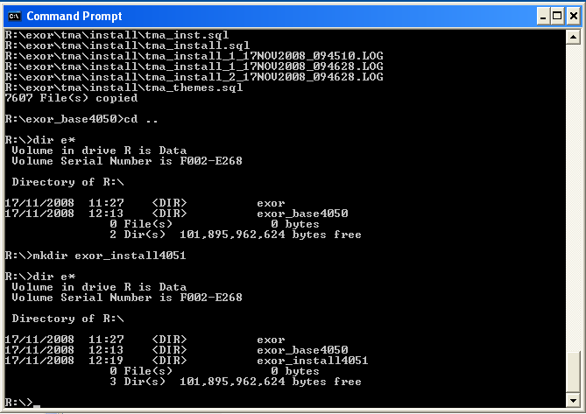

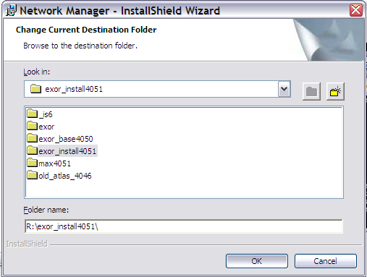

… which should then be copied onto the <exor_base>

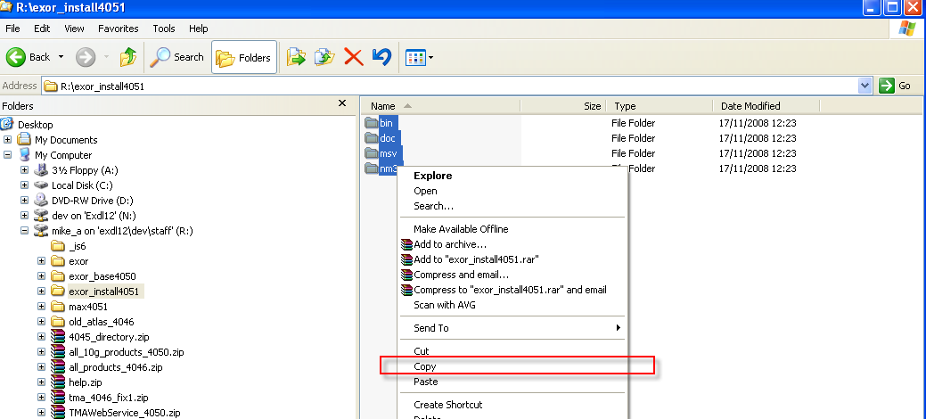

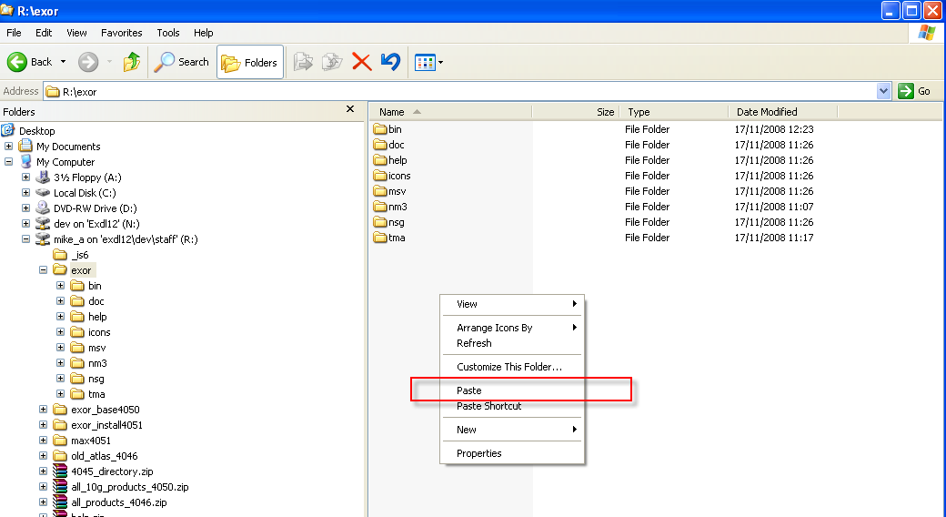

- Network Manager
  - Installation of the Network Manager Software files
To install the software components for Network Manager execute the setup_network_manager_4100.exe and follow the on-screen prompts.

Extremely Important (When Upgrading):

This is a patch release to be installed on top of release 4.0.5.2 (or higher i.e. 4.0.5.3 or 4.0.5.4)

It is crucial that when selecting the ‘Destination Folder’, you select that directory under which the existing 4.0.5.2 (or higher) software resides.

When the wizard completes, the necessary client and server software files will have been installed.

Notes:
A password is required to be entered during this process. If you are not sure of the password contact support@exorcorp.com.

  - Highways Owner Account
This section provides details of steps involved in creating as owner for all exor database objects.

Important:

Only perform the steps outlined in this section if you do not already have a ‘Highways Owner’ account. If you are upgrading Network Manager then please skip to section 3.3.

    - Before you start:

Where instructed to change to a directory before running a script, it is assumed that you are running SQL*PLUS from a DOS Command prompt.

If you are running SQL*PLUS in windows you should set the 'start in' directory of the SQL*PLUS shortcut to simulate the change of directory.

If you do not run SQL*PLUS from the directory stated in each step of the guide, the installation will fail.

Also, whilst following the instructions in this section you will be required to know the location of <exor_base>. You may recall that whilst undertaking the tasks in Chapter 2 you will have installed software into the location referred to as <exor_base>, for example, C:\EXOR.

    - Creation of a Highways Owner

The following paragraphs should be used to create a new schema for the implementation of Network Manager and any other subsequent exor application.

Tablespace Requirements

The following tablespaces (or equivalents) should be made available on your server:

HIGHWAYS Default Table Space. Can be a different name if required.

TEMP Default temporary Tablespace for users. Can be a different name.

Data Dictionary Privileges

Login to SQL*PLUS as the SYS user on the client PC and run the following command :

start <exor_base>\nm3\install\hig_sys_grants

The higowner script

Login to SQL*PLUS as the SYSTEM user on the client PC and run the following command:

start <exor_base>\nm3\install\higowner

This script will prompt you for the following information:

Prompt | Meaning
Highways Owner Name | This should be the name to be given to your highways owner
Owner’s Password | Password for highways owner
Default Tablespace | Default Tablespace for highways owner
Temporary Tablespace | Temporary Tablespace for highways owner
System Start Date | This is the earliest date at which data is valid in your database
Admin Type Code | Code for the default admin unit type
Admin Type Description | Description for the default admin unit type
Admin Unit Code | Code for the default Admin Unit
Admin Unit Description | Description for the default Admin Unit

You will now have a new Oracle user set up with all relevant privileges to run the highways application. Also the system start date for your database will have been set and Top level Admin Unit created for your default Admin Unit Type.

  - Network Manager Server Install/Upgrade
This section provides details of steps involved in installing/upgrading the server components for Network Manager.

All customers will either have to install Network Manager for the first time or upgrade their existing version to 4.1.0.0.

Important:
This product will require upgrading before any other 4.1.0.0 product upgrades.

    - Before you Start

Before proceeding please ensure that the pre-requisites mentioned in Section 2.3 of this document are met.

Also, please be aware of the following;

Where instructed to change to a directory before running a script, it is assumed that you are running SQL*PLUS from a DOS Command prompt.

If you are running SQL*PLUS in windows you should set the 'start in' directory of the SQL*PLUS shortcut to simulate the change of directory.

If you do not run SQL*PLUS from the directory stated in each step of the guide, the installation will fail.

Also, whilst following the instructions in this section you will be required to know the location of <exor_base>. You may recall that whilst undertaking the tasks in Section 3.1 you will have implemented software into the location referred to as <exor_base>, for example, C:\EXOR.

    - Typical problems that you may encounter

It is possible that, when you are running some of the upgrade scripts, errors may be reported saying that objects already exist in the database or that columns already exist on tables. These errors can generally be ignored. If you are in any doubt, please contact the Exor support desk for guidance.

The upgrade procedures will also attempt to install database roles in the highways owner account that are necessary for the system to operate correctly. You may find that errors are produced when running the upgrade scripts to the effect that the role names being created are already used by existing roles or users. These errors can be ignored as they simply mean that the roles being created already exist.

Also during install/upgrade Warning messages may appear saying that compilation errors have occurred. These warnings can be ignored, since invalid objects will be recompiled prompt later on in the install/upgrade. However it will be of concern if compilation errors still occur following the re-compilation.

    - Creation of the Exor_Core User and Objects

The following should be used to create a new schema for the implementation of Context Setting.

Login to SQL*PLUS as the SYSTEM user on the client PC and
run the following command:

start <exor_base>\nm3\install\exor_core_user_creation

Login to SQL*PLUS as the user EXOR_CORE Password EXOR_CORE on the client PC and
run the following command:

start <exor_base>\nm3\install\exor_core_objects

Then continue with Creation of a Highways Owner

    - Install of Network manager

To create the base data and objects for Network Manager modules;

Change directory to <exor_base>\nm3\install

Login to SQL*PLUS as the highways owner on the client PC and run the following command:
start nm_inst

You will be prompted to enter the path of the location of your highways software. This should be name of the directory, including disk identifier and a trailing slash character, referred to as <exor_base>.

For example, if you installed your highways software in a directory called EXOR on your C drive, you would enter the following when prompted.

C:\EXOR\

When you have supplied this value, you will be prompted to confirm that it is correct and asked whether you wish to continue.

If the value specified is not correct or does not end with a slash character, you will be given an error message and the installation script will abort. You will then need to login to SQL*PLUS again and rerun the script.

When the script has completed, all the Network Manager objects and data will have been installed.

Checking Log File(s)

The following log files are produced in the working directory. At the end of the installation, the files can be viewed to check for any errors that could have occurred during installation.

nm3_install_1_<date&time>.LOG
nm3_install_2_<date&time>.LOG

Note:
it is perfectly normal for the NM3SDE package to not compile if an SDE schema does not exist or if the highways owner has no privilege to read SDE objects.

Log files should be emailed to support@exorcorp.com to allow exor support staff to verify the install has been successful.

    - Upgrade of Network Manager

This section describes the steps necessary to upgrade Network Manager to 4.1.0.0

Important
The server upgrade relies on invoking scripts shipped with the previous release. Therefore it is essential that the software was installed into the correct destination folder, as instructed in the previous chapter.
To upgrade the base data and objects for the Network Manager modules;

- Change directory to <exor_base>\nm3\install

- Login to SQL*PLUS as the highways owner on the client PC

- Run the following command
start nm4052_nm4100.sql

- You will be prompted to enter the path of the location of your highways software. This should be name of the directory, including disk identifier and a trailing slash character, referred to as <exor_base>.

For example, if you installed your highways software in a directory called EXOR on your C drive, you would enter the following when prompted.

C:\EXOR\

- When you have supplied this value, you will be prompted to confirm that it is correct and asked whether you wish to continue.

- If the value specified is not correct or does not end with a slash character, you will be given an error message and the installation script will abort. You will then need to login to SQL*PLUS again and rerun the script.

- When the script has completed, all the Network Manager objects and data will have been upgraded.

Checking Log File(s)

The following log files are produced in the working directory. At the end of the upgrade, they can be viewed to check for any errors that could have occurred during the upgrade process.

nm4052_nm4100_1_<date&time>.LOG
nm4052_nm4100_2_<date&time>.LOG

Log files should be emailed to support@exorcorp.com to allow exor support staff to verify the upgrade has been successful.

Due to interdependencies between some Exor products, please ignore all compilation errors until all of your products have been upgraded.

    - Post Install/Upgrade Tasks

exor_version.txt

Before accessing Network Manager you must check the file exor_version.txt.

This file is referenced in Windows Registry setting ‘EXOR_VERSION’ and by default can be located in the <exor_base>\bin directory.

Ensure that the entry for Network Manager is set accordingly;

NET=4.1.0.0
HIG=4.1.0.0
AST=4.1.0.0
DOC=4.1.0.0
WMP=4.1.0.0

Creation Of Additional Database Objects

Once an install has been completed the following batch files must to be run;

- import_nm_upload_files.bat
- ldjava_10g.bat (for customers with an Oracle 10gR2 RDBMS)

These may be found in the <exor_base>\nm3\install\ directory and should be run form the command prompt.

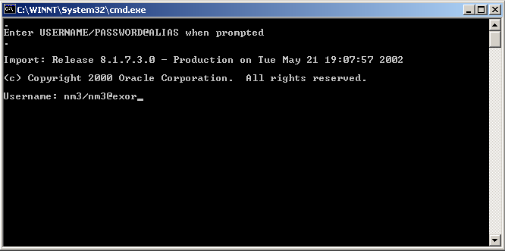

FoY

You will be prompted for the Username of the Highways Owner. Enter the Username/Password@alias then press Enter, e.g. nm3/nm3@exor

Synonyms

Highways product option HIGPUBSYN is used to dictate whether or not Public database synonyms are used.

On first time installation of Network Manager synonyms are NOT created. So to create synonyms following installation, use the Highways application to set product option HIGPUBSYN and then within SQL*Plus run the following command;

EXECUTE nm3ddl.refresh_all_synonyms;

Note:
if you opt to not use Public Synonyms, then Private synonyms are created for all subordinate users when the above command is executed.

Configuring NM3WEB

This section provides details of steps involved in configuring the Gateway Database Access Descriptor to allow access to the Web modules used within Highways by Exor.

These include modules such as the
CSV Loaders - HIGWEB2030
Engineering Dynamic Segmentation - NMWEB0020.

In this section <apache_html> refers to the base directory for files accessed through the Apache web server. By default this is ORACLE_HOME\apache\apache\htdocs.

A Database Access Descriptor (DAD) must be created to handle the connection to the database by the web server.

From the Oracle Apache Admin page (by default this is http://<host>/index.html) select mod_plsql.
Select Gateway Database Access Descriptor Settings.

Select Add Default (blank configuration).

Database Access Descriptor Name should be NM3WEB

Schema Name should be blank.

Fill in user, password and database as required. You can leave the password and/or username blank to force the user to enter them (recommended).

Authentication Mode should be Basic.

Session Cookie should be blank.

Create a Stateful Session? Should be No.

Note that if Running on Oracle Standard Edition this should be set to Yes.

Enable Connection Pooling? Should be Yes.

Default (Home) Page should be nm3web.main_menu.

Document Table should be nm_upload_files.

Document Access path should be the value set for Product Option WEBDOCPATH. The standard metadata value is docs

Document Access Procedure should be nm3web.process_download

Click OK button at top of page.

Note:
In order to access the Web Modules the User must be granted the appropriate Roles for the Module. Refer to the General System Admin Guide for more information on User Roles

Forms 9i/10g Specific Configuration

There are certain product options which must be set according to the Oracle forms version that is being used to run the exor application.

NOT_6I_REP

This should be set to Y

REPURL

The value of this product option should be set to the URL that identifies the 9i or 10g Application Server Reports Server.

e.g.
http://<app_server>:7778/reports/rwservlet?server=<rep_server>

Date Format Masks

There are a couple of registry entries that can be used to re-define the default Forms date mask.

These registry entries should be added to the same area of the registry as the FORMS_PATH/FORMS90_PATH e.g

HKEY_LOCAL_MACHINE\SOFTWARE\Oracle

Note:
If running Oracle forms via an application server then only the registry on the application server needs to be updated.

Registry Setting
FORMS_USER_DATE_FORMAT
or
FORMS90_USER_DATE_FORMAT

Example Value data
DD-MON-RRRR|DDMONRRRR|DD/MM/RRRR

Used to set the allowed input format mask(s).
Multiple masks should be separated with a pipe character.
The example above allows the user to enter the 1st of Jan 2005 as :-

01-JAN-2005
01-JAN-05
01JAN2005
01JAN05
01/01/2005
01/01/05

Registry Setting
FORMS60_OUTPUT_DATE_FORMAT
Or
FORMS90_OUTPUT_DATE_FORMAT

Example Value data
DD-MON-RRRR

Used (rather unsurprisingly) by Forms to format the displayed Date.
i.e. If the user enters the date as 01JAN05 the displayed value is changed to 01-JAN-2005 when the user leaves the field or the form is validated. This mask is also applied when querying in a Form.

Only one value should be set for this entry.

    - Additional Configuration

Consult the documentation that accompanies this release for details of any additional configuration that may be required following an install/upgrade.

For example, to obtain details of product options, and for details of new product features/amendments.

Important:
It is highly recommended that you do this before attempting to use the application.

    - EXOR_JPG.JAR

New icons should be configured when performing an Upgrade only.

Copy the new EXOR_JPG.JAR from the <exor_base>/icons/java folder to the <forms_home>/java folder on the application server.

Users may need to clear their Java Initiator/JRE caches to see the changes.

    - Spatial Configuration

Specific information regarding the registration of spatial layers can be found in the “Locator and Web Mapping” document.

- Maintenance Manager
  - Implementation of the Maintenance Manager Software files

To install the software components for Maintenance Manager execute the setup_maintenance_manager_4100.exe and follow the on-screen prompts.

Extremely Important (When Upgrading):

This is a patch release to be installed on top of release 4.0.5.2

It is crucial that when selecting the ‘Destination Folder’, you select that directory under which the existing 4.0.5.2 software resides.

When the wizard completes, the necessary client and server software files will have been installed.

Notes:
A password is required to be entered during this process. If you are not sure of the password contact support@exorcorp.com.

Important:
All exor applications that you install must go into the same destination – what is often referred to as <exor_base>.

To support different roll-out models, you can decide to just install Client or Server or both sets of components into the <exor_base>.

  - Maintenance Manager Server Install/Upgrade

This chapter provides details of steps involved in installing/upgrading the server components for Maintenance Manager.

Important:
This product will require installing/upgrading after Network Manager.

    - Before you Start

Before proceeding please ensure that the pre-requisites mentioned in Section 2.3 of this document are met.

Also, please be aware of the following;

Where instructed to change to a directory before running a script, it is assumed that you are running SQL*PLUS from a DOS Command prompt.

If you are running SQL*PLUS in windows you should set the 'start in' directory of the SQL*PLUS shortcut to simulate the change of directory.

If you do not run SQL*PLUS from the directory stated in each step of the guide, the installation will fail.

Also, whilst following the instructions in this section you will be required to know the location of <exor_base>. You may recall that whilst undertaking the tasks in Section 4.1 you will have implemented software into the location referred to as <exor_base>, for example, C:\EXOR.

    - Typical problems that you may encounter

It is possible that, when you are running some of the upgrade scripts, errors may be reported saying that objects already exist in the database or that columns already exist on tables. These errors can generally be ignored. If you are in any doubt, please contact the Exor support desk for guidance.

The upgrade procedures will also attempt to install database roles in the highways owner account that are necessary for the system to operate correctly. You may find that errors are produced when running the upgrade scripts to the effect that the role names being created are already used by existing roles or users. These errors can be ignored as they simply mean that the roles being created already exist.

Also during upgrade Warning messages may appear saying that compilation errors have occurred. These warnings can be ignored, since invalid objects will be recompiled prompt later on in the upgrade. However it will be of concern if compilation errors still occur following the re-compilation.

    - Install of Maintenance Manager

To create the base data and objects for Maintenance Manager modules;

Change directory to <exor_base>\mai\install

Login to SQL*PLUS as the highways owner on the client PC and run the following command:
start mai_inst

You will be prompted to enter the path of the location of your highways software. This should be name of the directory, including disk identifier and a trailing slash character, referred to as <exor_base>.

For example, if you installed your highways software in a directory called EXOR on your C drive, you would enter the following when prompted.

C:\EXOR\

When you have supplied this value, you will be prompted to confirm that it is correct and asked whether you wish to continue.

If the value specified is not correct or does not end with a slash character, you will be given an error message and the installation script will abort. You will then need to login to SQL*PLUS again and rerun the script.

When the script has completed, all the Maintenance Manager objects and data will have been installed.

Checking Log File(s)

The following log files are produced in the working directory. At the end of the installation, the files can be viewed to check for any errors that could have occurred during installation.

mai_install_1_<date&time>.LOG
mai_install_2_<date&time>.LOG

Log files should be emailed to support@exorcorp.com to allow exor support staff to verify the install has been successful.

    - Upgrade of Maintenance Manager

This section describes the steps necessary to upgrade Maintenance Manager to 4.1.0.0

Important
The server upgrade relies on invoking scripts shipped with the previous release. Therefore it is essential that the software was installed into the correct destination folder, as instructed in the previous chapter.

To upgrade the base data and objects for the Maintenance Manager modules;

- Change directory to <exor_base>\mai\install

- Login to SQL*PLUS as the highways owner on the client PC

- The same script is used to upgrade from the previous version shown in Section 2.2.
Run the following command

start mai4052_mai4100.sql

- You will be prompted to enter the path of the location of your highways software. This should be name of the directory, including disk identifier and a trailing slash character, referred to as <exor_base>.

For example, if you installed your highways software in a directory called EXOR on your C drive, you would enter the following when prompted.

C:\EXOR\

- When you have supplied this value, you will be prompted to confirm that it is correct and asked whether you wish to continue.

- If the value specified is not correct or does not end with a slash character, you will be given an error message and the installation script will abort. You will then need to login to SQL*PLUS again and rerun the script.

- When the script has completed, all the Maintenance Manager objects and data will have been upgraded.

Checking Log File(s)

The following log files are produced in the working directory. At the end of the upgrade, they can be viewed to check for any errors that could have occurred during the upgrade process.

mai4052_mai4100_1_<date&time>.LOG
mai4052_mai4100_2_<date&time>.LOG

Log files should be emailed to support@exorcorp.com to allow exor support staff to verify the upgrade has been successful.

Due to interdependencies between some Exor products, please ignore all compilation errors until all of your products have been upgraded.

    - Mandatory Configuration

exor_version.txt

Before accessing Maintenance Manager you must check the file exor_version.txt.

This file is referenced in Windows Registry setting ‘EXOR_VERSION’ and by default can be located in the <exor_base>\bin directory.

Ensure that the entry for Maintenance Manager is set accordingly;

MAI=4.1.0.0

    - Additional Configuration

Consult the documentation that accompanies this release for details of any additional configuration that may be required following an install/upgrade.

For example, to obtain details of product options, and for details of new product features/amendments.

Important:
It is highly recommended that you do this before attempting to use the application.

    - Spatial Configuration

Specific information regarding the registration of spatial layers can be found in the “Locator and Web Mapping” document.

- Enquiry Manager
  - Implementation of the Enquiry Manager Software files

To install the software components for Enquiry Manager execute the setup_enquiry_manager_4100.exe and follow the on-screen prompts.

Extremely Important (When Upgrading):

This is a patch release to be installed on top of release 4.0.5.2

It is crucial that when selecting the ‘Destination Folder’, you select that directory under which the existing 4.0.5.2 software resides.

When the wizard completes, the necessary client and server software files will have been installed.

Notes:
A password is required to be entered during this process. If you are not sure of the password contact support@exorcorp.com.

Important:
All exor applications that you install must go into the same destination – what is often referred to as <exor_base>.

To support different roll-out models, you can decide to just install Client or Server or both sets of components into the <exor_base>.

  - Enquiry Manager Server Install/Upgrade

This chapter provides details of steps involved in installing/upgrading the server components for Enquiry Manager.

Important:
This product will require installing/upgrading after Network Manager and Maintenance Manager.

    - Before you Start

Before proceeding please ensure that the pre-requisites mentioned in Section 2.3 of this document are met.

Also, please be aware of the following;

Where instructed to change to a directory before running a script, it is assumed that you are running SQL*PLUS from a DOS Command prompt.

If you are running SQL*PLUS in windows you should set the 'start in' directory of the SQL*PLUS shortcut to simulate the change of directory.

If you do not run SQL*PLUS from the directory stated in each step of the guide, the installation will fail.

Also, whilst following the instructions in this section you will be required to know the location of <exor_base>. You may recall that whilst undertaking the tasks in Section 5.1 you will have implemented software into the location referred to as <exor_base>, for example, C:\EXOR.

    - Typical problems that you may encounter

It is possible that, when you are running some of the upgrade scripts, errors may be reported saying that objects already exist in the database or that columns already exist on tables. These errors can generally be ignored. If you are in any doubt, please contact the Exor support desk for guidance.

The upgrade procedures will also attempt to install database roles in the highways owner account that are necessary for the system to operate correctly. You may find that errors are produced when running the upgrade scripts to the effect that the role names being created are already used by existing roles or users. These errors can be ignored as they simply mean that the roles being created already exist.

Also during upgrade Warning messages may appear saying that compilation errors have occurred. These warnings can be ignored, since invalid objects will be recompiled prompt later on in the upgrade. However it will be of concern if compilation errors still occur following the re-compilation.

    - Install of Enquiry Manager

To create the base data and objects for Enquiry Manager modules;

Change directory to <exor_base>\pem\install

Login to SQL*PLUS as the highways owner on the client PC and run the following command:
start pem_inst

You will be prompted to enter the path of the location of your highways software. This should be name of the directory, including disk identifier and a trailing slash character, referred to as <exor_base>.

For example, if you installed your highways software in a directory called EXOR on your C drive, you would enter the following when prompted.

C:\EXOR\

When you have supplied this value, you will be prompted to confirm that it is correct and asked whether you wish to continue.

If the value specified is not correct or does not end with a slash character, you will be given an error message and the installation script will abort. You will then need to login to SQL*PLUS again and rerun the script.

When the script has completed, all the Enquiry Manager objects and data will have been installed.

Checking Log File(s)

The following log files are produced in the working directory. At the end of the installation, the files can be viewed to check for any errors that could have occurred during installation.

pem_install_1_<date&time>.LOG
pem_install_2_<date&time>.LOG

Log files should be emailed to support@exorcorp.com to allow exor support staff to verify the install has been successful.

    - Upgrade of Enquiry Manager

This section describes the steps necessary to upgrade Enquiry Manager to 4.1.0.0

Important
The server upgrade relies on invoking scripts shipped with the previous release. Therefore it is essential that the software was installed into the correct destination folder, as instructed in the previous chapter.

To upgrade the base data and objects for the Enquiry Manager modules;

- Change directory to <exor_base>\pem\install

- Login to SQL*PLUS as the highways owner on the client PC

- The same script is used to upgrade from the previous version shown in Section 2.2.
Run the following command

start pem4052_pem4100.sql

- You will be prompted to enter the path of the location of your highways software. This should be name of the directory, including disk identifier and a trailing slash character, referred to as <exor_base>.

For example, if you installed your highways software in a directory called EXOR on your C drive, you would enter the following when prompted.

C:\EXOR\

- When you have supplied this value, you will be prompted to confirm that it is correct and asked whether you wish to continue.

- If the value specified is not correct or does not end with a slash character, you will be given an error message and the installation script will abort. You will then need to login to SQL*PLUS again and rerun the script.

- When the script has completed, all the Enquiry Manager objects and data will have been upgraded.

Checking Log File(s)

The following log files are produced in the working directory. At the end of the upgrade, they can be viewed to check for any errors that could have occurred during the upgrade process.

pem4052_pem4100_1_<date&time>.LOG
pem4052_pem4100_2_<date&time>.LOG

Log files should be emailed to support@exorcorp.com to allow exor support staff to verify the upgrade has been successful.

Due to interdependencies between some Exor products, please ignore all compilation errors until all of your products have been upgraded.

    - Mandatory Configuration

exor_version.txt

Before accessing Enquiry Manager you must check the file exor_version.txt.

This file is referenced in Windows Registry setting ‘EXOR_VERSION’ and by default can be located in the <exor_base>\bin directory.

Ensure that the entry for Enquiry Manager is set accordingly;

PEM=4.1.0.0

    - Additional Configuration

Consult the documentation that accompanies this release for details of any additional configuration that may be required following an install/upgrade.

For example, to obtain details of product options, and for details of new product features/amendments.

Important:
It is highly recommended that you do this before attempting to use the application.

    - Spatial Configuration

Specific information regarding the registration of spatial layers can be found in the “Locator and Web Mapping” document.
- Street Gazetteer Manager
  - Implementation of the Street Gazetteer Manager Software files
To install the software components for Street Gazetteer Manager execute the setup_street_gazetteer_manager_4100.exe and follow the on-screen prompts.

Extremely Important (When Upgrading):

This is a patch release to be installed on top of release 4.0.5.2

It is crucial that when selecting the ‘Destination Folder’, you select that directory under which the existing 4.0.5.2 software resides.

When the wizard completes, the necessary client and server software files will have been installed.

Notes:
A password is required to be entered during this process. If you are not sure of the password contact support@exorcorp.com.

  - Street Gazetteer Manager Server Install/Upgrade
This chapter provides details of steps involved in installing/upgrading the server components for Street Gazetteer Manager.

Important:
This product will require upgrading after Network Manager and before TMA Manager.

    - Before you Start

Before proceeding please ensure that the pre-requisites mentioned in Section 2.3 of this document are met.

Also, please be aware of the following;

Where instructed to change to a directory before running a script, it is assumed that you are running SQL*PLUS from a DOS Command prompt.

If you are running SQL*PLUS in windows you should set the 'start in' directory of the SQL*PLUS shortcut to simulate the change of directory.

If you do not run SQL*PLUS from the directory stated in each step of the guide, the installation will fail.

Also, whilst following the instructions in this section you will be required to know the location of <exor_base>. You may recall that whilst undertaking the tasks in Section 6.1 you will have implemented software into the location referred to as <exor_base>, for example, C:\EXOR.

    - Typical problems that you may encounter

It is possible that, when you are running some of the upgrade scripts, errors may be reported saying that objects already exist in the database or that columns already exist on tables. These errors can generally be ignored. If you are in any doubt, please contact the Exor support desk for guidance.

The upgrade procedures will also attempt to install database roles in the highways owner account that are necessary for the system to operate correctly. You may find that errors are produced when running the upgrade scripts to the effect that the role names being created are already used by existing roles or users. These errors can be ignored as they simply mean that the roles being created already exist.

Also during upgrade Warning messages may appear saying that compilation errors have occurred. These warnings can be ignored, since invalid objects will be recompiled prompt later on in the upgrade. However it will be of concern if compilation errors still occur following the re-compilation.

    - Install of Street Gazetteer manager

To create the base data and objects for Street Gazetteer Manager modules;

Change directory to <exor_base>\nsg\install

Login to SQL*PLUS as the highways owner on the client PC and run the following command:
start nsg_inst

You will be prompted to enter the path of the location of your highways software. This should be name of the directory, including disk identifier and a trailing slash character, referred to as <exor_base>.

For example, if you installed your highways software in a directory called EXOR on your C drive, you would enter the following when prompted.

C:\EXOR\

When you have supplied this value, you will be prompted to confirm that it is correct and asked whether you wish to continue.

If the value specified is not correct or does not end with a slash character, you will be given an error message and the installation script will abort. You will then need to login to SQL*PLUS again and rerun the script.

When the script has completed, all the Street Gazetteer Manager objects and data will have been installed.

Checking Log File(s)

The following log files are produced in the working directory. At the end of the installation, the files can be viewed to check for any errors that could have occurred during installation.

nsg_install_1_<date&time>.LOG
nsg_install_2_<date&time>.LOG

Log files should be emailed to support@exorcorp.com to allow exor support staff to verify the install has been successful.

    - Upgrade of Street Gazetteer Manager

This section describes the steps necessary to upgrade Street Gazetteer Manager to 4.1.0.0

Important
The server upgrade relies on invoking scripts shipped with the previous release. Therefore it is essential that the software was installed into the correct destination folder, as instructed in the previous chapter.

To upgrade the base data and objects for the Street Gazetteer Manager modules;

- Change directory to <exor_base>\nsg\install

- Login to SQL*PLUS as the highways owner on the client PC

- The same script is used to upgrade from the previous version shown in Section 2.2.
Run the following command

start nsg4052_nsg4100.sql

- You will be prompted to enter the path of the location of your highways software. This should be name of the directory, including disk identifier and a trailing slash character, referred to as <exor_base>.

For example, if you installed your highways software in a directory called EXOR on your C drive, you would enter the following when prompted.

C:\EXOR\

- When you have supplied this value, you will be prompted to confirm that it is correct and asked whether you wish to continue.

- If the value specified is not correct or does not end with a slash character, you will be given an error message and the installation script will abort. You will then need to login to SQL*PLUS again and rerun the script.

- When the script has completed, all the Street Gazetteer Manager objects and data will have been upgraded.

Checking Log File(s)

The following log files are produced in the working directory. At the end of the upgrade, they can be viewed to check for any errors that could have occurred during the upgrade process.

nsg4052_nsg4100_1_<date&time>.LOG
nsg4052_nsg4100_2_<date&time>.LOG

Log files should be emailed to support@exorcorp.com to allow exor support staff to verify the upgrade has been successful.

Due to interdependencies between some Exor products, please ignore all compilation errors until all of your products have been upgraded.

    - Mandatory Configuration

exor_version.txt

Before accessing Street Gazetteer Manager you must check the file exor_version.txt.

This file is referenced in Windows Registry setting ‘EXOR_VERSION’ and by default can be located in the <exor_base>\bin directory.

Ensure that the entry for Street Gazetteer Manager is set accordingly;

NSG=4.1.0.0

- TMA Manager
  - Implementation of the TMA Manager Software files

To install the software components for TMA Manager execute the setup_tma_manager_4100.exe and follow the on-screen prompts.

Extremely Important (When Upgrading):

This is a patch release to be installed on top of release 4.0.5.2

It is crucial that when selecting the ‘Destination Folder’, you select that directory under which the existing 4.0.5.2 software resides.

When the wizard completes, the necessary client and server software files will have been installed.

Notes:
A password is required to be entered during this process. If you are not sure of the password contact support@exorcorp.com.

  - TMA Manager Server Install/Upgrade
This chapter provides details of steps involved in installing/upgrading the server components for TMA Manager.

Important:
This product will require installing/upgrading after Network Manager and Street Gazetteer Manager.

    - Before you Start

Before proceeding please ensure that the pre-requisites mentioned in Section 2.3 of this document are met.

Also, please be aware of the following;

Extremely Important (When Upgrading):

Before upgrading TMA Manager shutdown the TMA Web Server and Restart it, after successfully upgrading TMA Manager.

Where instructed to change to a directory before running a script, it is assumed that you are running SQL*PLUS from a DOS Command prompt.

If you are running SQL*PLUS in windows you should set the 'start in' directory of the SQL*PLUS shortcut to simulate the change of directory.

If you do not run SQL*PLUS from the directory stated in each step of the guide, the installation will fail.

Also, whilst following the instructions in this section you will be required to know the location of <exor_base>. You may recall that whilst undertaking the tasks in Section 7.1 you will have implemented software into the location referred to as <exor_base>, for example, C:\EXOR.

    - Typical problems that you may encounter

It is possible that, when you are running some of the upgrade scripts, errors may be reported saying that objects already exist in the database or that columns already exist on tables. These errors can generally be ignored. If you are in any doubt, please contact the Exor support desk for guidance.

The upgrade procedures will also attempt to install database roles in the highways owner account that are necessary for the system to operate correctly. You may find that errors are produced when running the upgrade scripts to the effect that the role names being created are already used by existing roles or users. These errors can be ignored as they simply mean that the roles being created already exist.

Also during upgrade Warning messages may appear saying that compilation errors have occurred. These warnings can be ignored, since invalid objects will be recompiled prompt later on in the upgrade. However it will be of concern if compilation errors still occur following the re-compilation.

    - Install of TMA Manager

To create the base data and objects for TMA Manager modules;

Change directory to <exor_base>\tma\install

Login to SQL*PLUS as the highways owner on the client PC and run the following command:
start tma_inst

You will be prompted to enter the path of the location of your highways software. This should be name of the directory, including disk identifier and a trailing slash character, referred to as <exor_base>.

For example, if you installed your highways software in a directory called EXOR on your C drive, you would enter the following when prompted.

C:\EXOR\

When you have supplied this value, you will be prompted to confirm that it is correct and asked whether you wish to continue.

If the value specified is not correct or does not end with a slash character, you will be given an error message and the installation script will abort. You will then need to login to SQL*PLUS again and rerun the script.

When the script has completed, all the TMA Manager objects and data will have been installed.

Checking Log File(s)

The following log files are produced in the working directory. At the end of the installation, the files can be viewed to check for any errors that could have occurred during installation.

tma_install_1_<date&time>.LOG
tma_install_2_<date&time>.LOG

Log files should be emailed to support@exorcorp.com to allow exor support staff to verify the install has been successful.

    - Upgrade of TMA Manager

This section describes the steps necessary to upgrade TMA Manager to 4.1.0.0

Important
The server upgrade relies on invoking scripts shipped with the previous release. Therefore it is essential that the software was installed into the correct destination folder, as instructed in the previous chapter.

To upgrade the base data and objects for the TMA Manager modules;

- Change directory to <exor_base>\tma\install

- Login to SQL*PLUS as the highways owner on the client PC

- The same script is used to upgrade from the previous version shown in Section 2.2.
Run the following command

start tma4052_tma4100.sql

- You will be prompted to enter the path of the location of your highways software. This should be name of the directory, including disk identifier and a trailing slash character, referred to as <exor_base>.

For example, if you installed your highways software in a directory called EXOR on your C drive, you would enter the following when prompted.

C:\EXOR\

- When you have supplied this value, you will be prompted to confirm that it is correct and asked whether you wish to continue.

- If the value specified is not correct or does not end with a slash character, you will be given an error message and the installation script will abort. You will then need to login to SQL*PLUS again and rerun the script.

- When the script has completed, all the TMA Manager objects and data will have been upgraded.

Checking Log File(s)

The following log files are produced in the working directory. At the end of the upgrade, they can be viewed to check for any errors that could have occurred during the upgrade process.

tma4052_tma4100_1_<date&time>.LOG
tma4052_tma4100_2_<date&time>.LOG

Log files should be emailed to support@exorcorp.com to allow exor support staff to verify the upgrade has been successful.

Due to interdependencies between some Exor products, please ignore all compilation errors until all of your products have been upgraded.

    - Mandatory Configuration

exor_version.txt

Before accessing TMA Manager you must check the file exor_version.txt.

This file is referenced in Windows Registry setting ‘EXOR_VERSION’ and by default can be located in the <exor_base>\bin directory.

Ensure that the entry for TMA Manager is set accordingly;

TMA=4.1.0.0

    - Web Service Install\Upgrade

After a successful install\upgrade of TMA Manager to version 4.1.0.0 the TMA Web Service will require either installation or upgrade.

Specific information regarding the installation or upgrade of the TMA Web Service can be found in the “4100_Installation_and_Upgrade_Guide_for_the_TMA_Web_Service.pdf” contained in the TMAWebService.zip.
ApEx

Log onto the ApEx application.

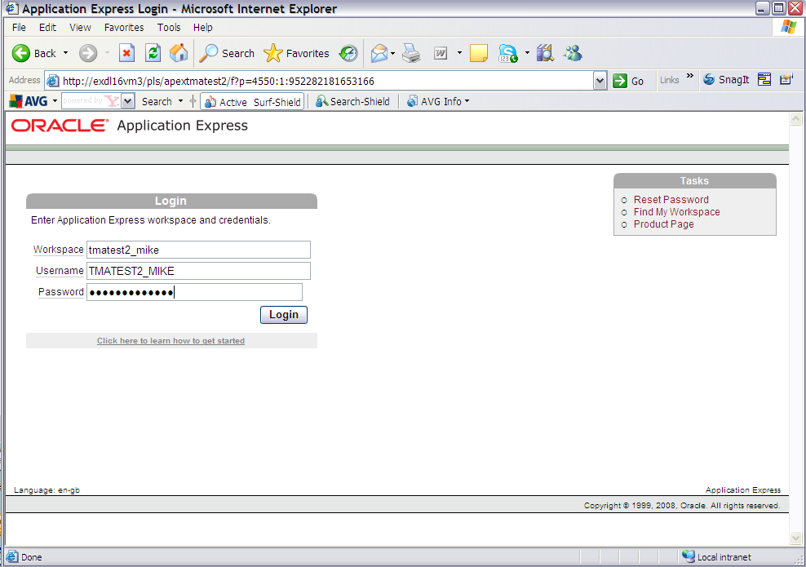

Select the 'Application Builder' option and import

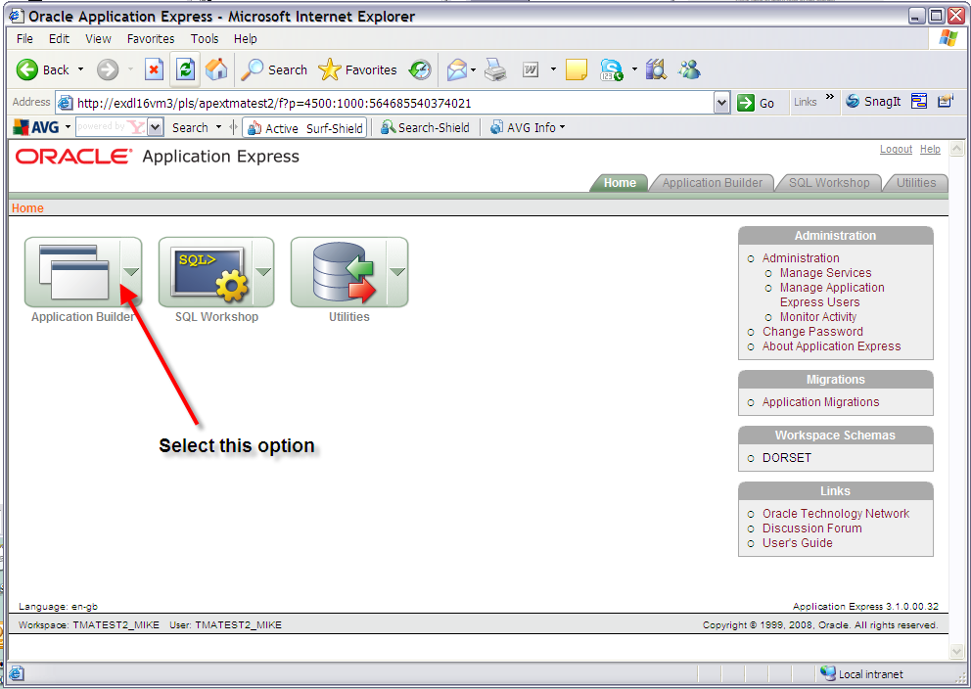

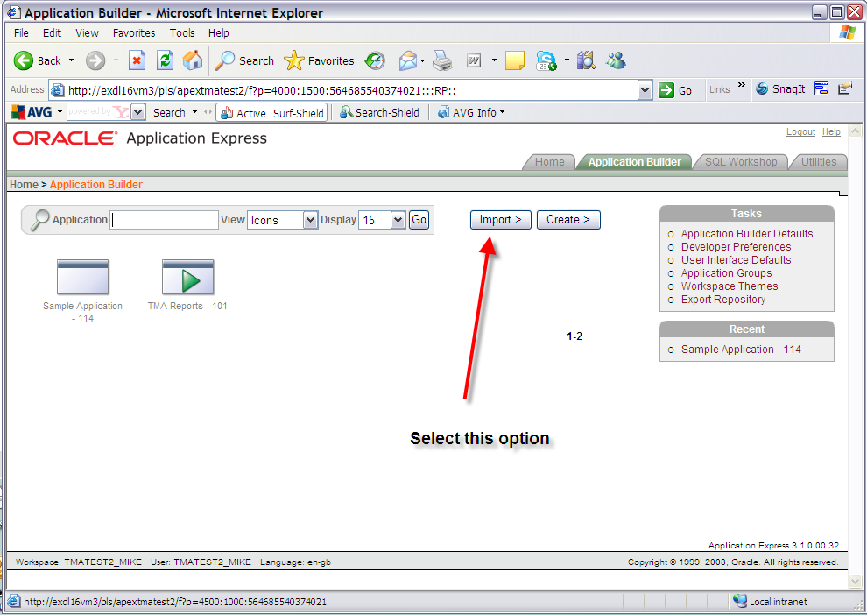

Import the ApEx Reports file under the directory <exor_base>\tma\admin\sql\tma_apex_rpts.sql

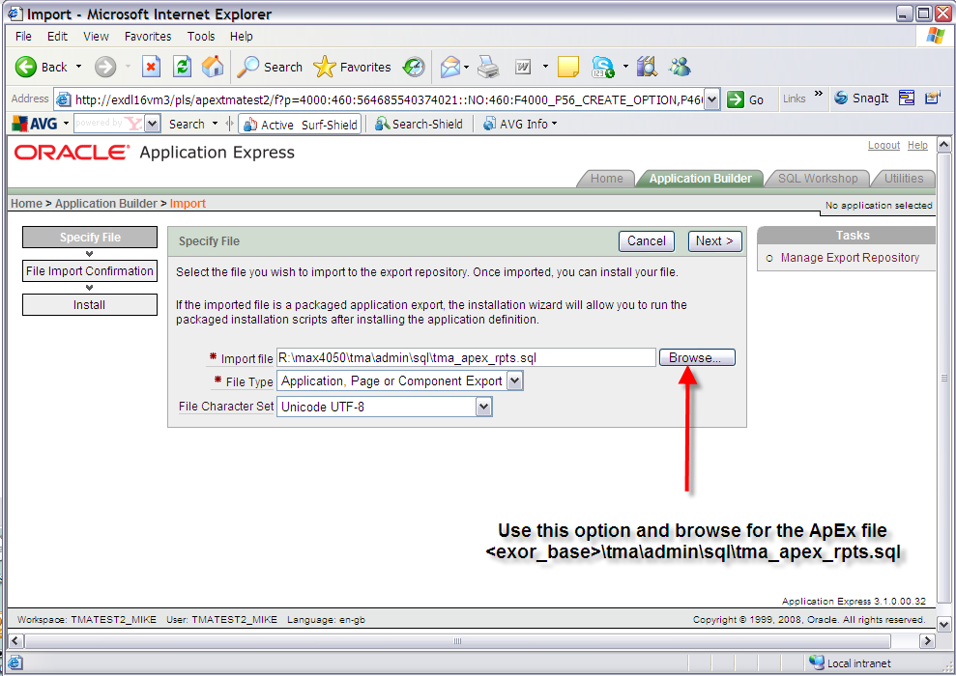

Once the file has been imported you will be met with this screen. Click the next button to proceed.

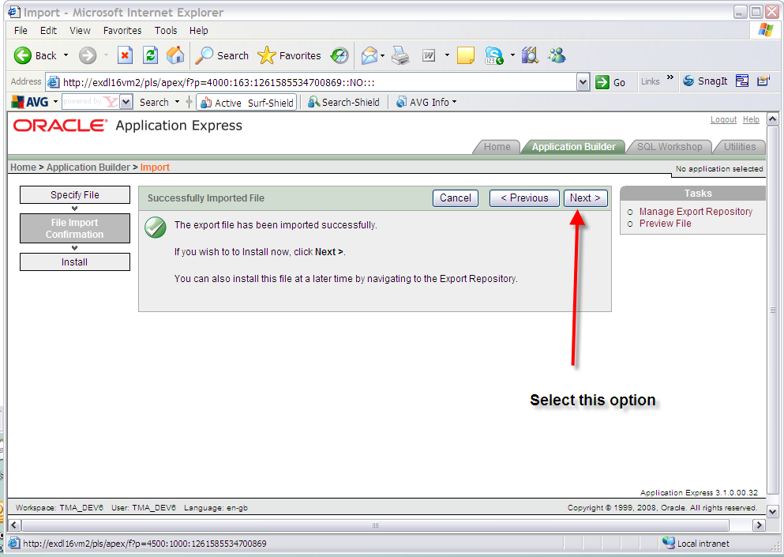

On the install application screen, which should be the screen presented, in the 'Install As Application' option select the 'Reuse Application ID 101 From Export' option and click the Install button. Parsing schema and build status should default values. Ensure that the Parsing Schema is the correct schema and the build status is ‘Run Application Only’.

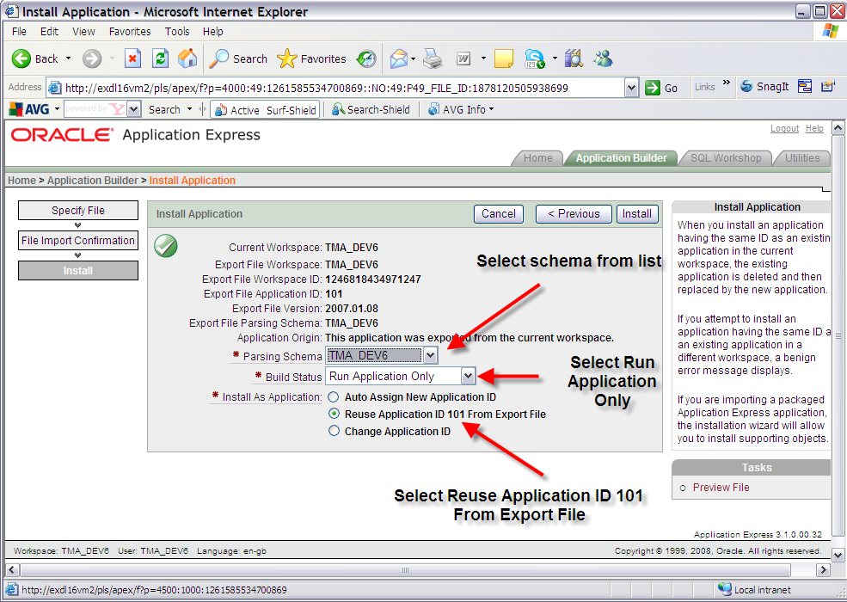

Click the Install button:

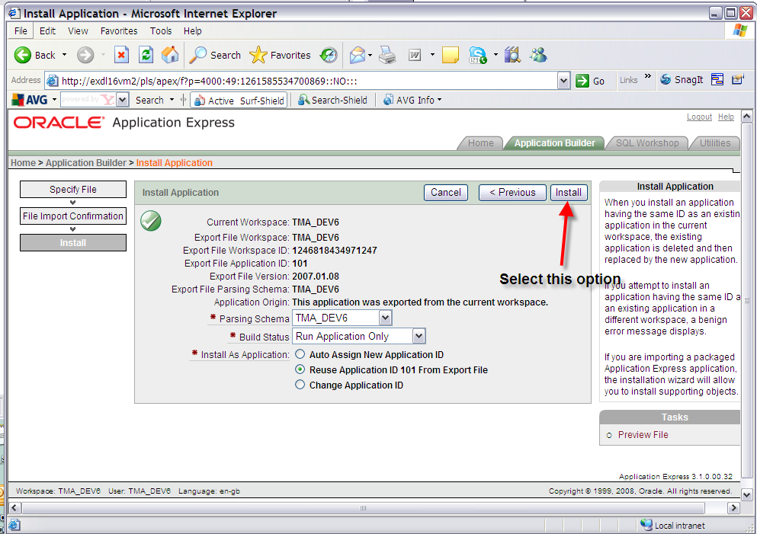

You should be presented with a 'Confirm Replace Application' screen. Click the 'Replace Existing Application' button.

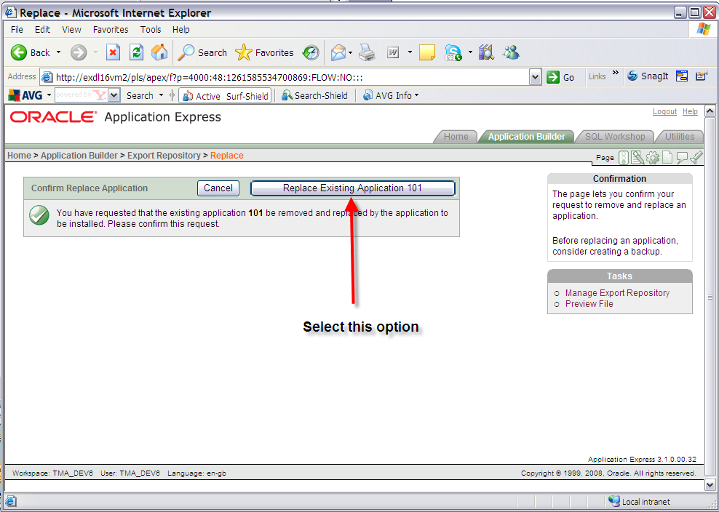

Exit the window which should read 'Application not available for edit'.

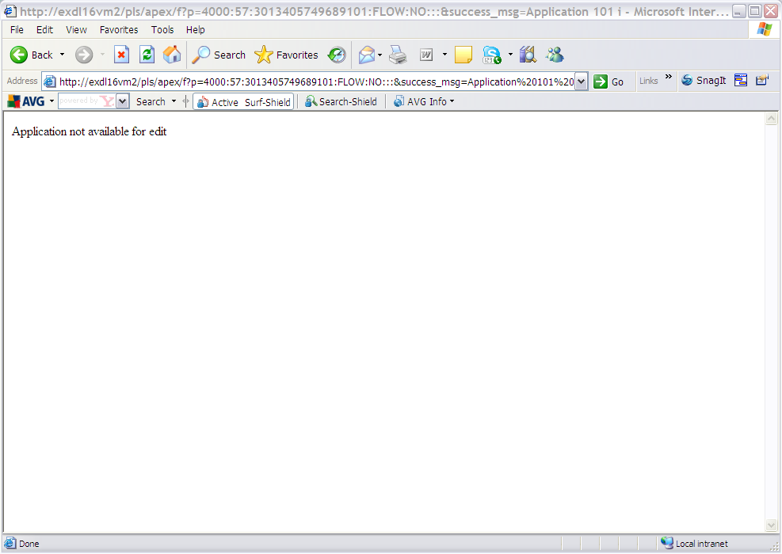

Test the reports from the TMA application.

- TMA API
  - Implementation of the TMA API Software files

To install the software components for TMA Manager execute the setup_tma_api_4100.exe and follow the on-screen prompts.

Extremely Important (When Upgrading):

This is a patch release to be installed on top of release 4.0.5.2

It is crucial that when selecting the ‘Destination Folder’, you select that directory under which the existing 4.0.5.2 software resides.

When the wizard completes, the necessary client and server software files will have been installed.

Notes:
A password is required to be entered during this process. If you are not sure of the password contact support@exorcorp.com.

  - TMA API Server Upgrade

This chapter provides details of steps involved in upgrading the server components for TMA Manager.

Important:
This product will require upgrading after Network Manager, Street Gazetteer Manager and TMA Manager.

    - Before you Start

Before proceeding please ensure that the pre-requisites mentioned in Section 2.3 of this document are met.

Also, please be aware of the following;

Extremely Important (When Upgrading):

Before upgrading TMA API shutdown the TMA External Notice API Web Server and Restart it, after successfully upgrading TMA API.

Where instructed to change to a directory before running a script, it is assumed that you are running SQL*PLUS from a DOS Command prompt.

If you are running SQL*PLUS in windows you should set the 'start in' directory of the SQL*PLUS shortcut to simulate the change of directory.

If you do not run SQL*PLUS from the directory stated in each step of the guide, the installation will fail.

Also, whilst following the instructions in this section you will be required to know the location of <exor_base>. You may recall that whilst undertaking the tasks in Section 8.1 you will have implemented software into the location referred to as <exor_base>, for example, C:\EXOR.

    - Typical problems that you may encounter

It is possible that, when you are running some of the upgrade scripts, errors may be reported saying that objects already exist in the database or that columns already exist on tables. These errors can generally be ignored. If you are in any doubt, please contact the Exor support desk for guidance.

The upgrade procedures will also attempt to install database roles in the highways owner account that are necessary for the system to operate correctly. You may find that errors are produced when running the upgrade scripts to the effect that the role names being created are already used by existing roles or users. These errors can be ignored as they simply mean that the roles being created already exist.

Also during upgrade Warning messages may appear saying that compilation errors have occurred. These warnings can be ignored, since invalid objects will be recompiled prompt later on in the upgrade. However it will be of concern if compilation errors still occur following the re-compilation.

  - TMA External Notice API Implementation
    - Deployment of API Software Files

This section provides details of steps involved in deploying the files that the api is composed of to the relevant location on the file system.

Important:
All Exor applications that you install must go into the same destination – what is often referred to as <exor_base>.

To deploy the software components for the api, execute the setup_tma_api.exe and follow the on-screen prompts.

When the wizard completes, the necessary software files will have been deployed. These are held in the API directory. Copy the API folder and contents to the tma\admin folder.

    - API Server Component Install/Upgrade

This section provides details of steps involved in installing the server components for the api.

Note, that there is no upgrade option; the software can be reinstalled as required.

Important:
The api will require installing after the TMA application.

Also please be aware of the following;

Where instructed to change to a directory before running a script, it is assumed that you are running SQL*PLUS from a DOS Command prompt.

If you are running SQL*PLUS in windows you should set the 'start in' directory of the SQL*PLUS shortcut to simulate the change of directory.

If you do not run SQL*PLUS from the directory stated in each step of the guide, the installation will fail.

Also, whilst following the instructions in this section you will be required to know the location of <exor_base>.

To create the base data and objects for api;

Change directory to <exor_base>\tma\admin\api

Login to SQL*PLUS as the highways owner on the client PC and run the following command

start tma_api_inst.sql

You will be prompted to enter the path of the location of your highways software. This should be name of the directory, including disk identifier and a trailing slash character, referred to as <exor_base>.

For example, if you installed your highways software in a directory called EXOR on your C drive, you would enter the following when prompted.

C:\EXOR\

When you have supplied this value, you will be prompted to confirm that it is correct and asked whether you wish to continue.

If the value specified is not correct or does not end with a slash character, you will be given an error message and the installation script will abort. You will then need to login to SQL*PLUS again and rerun the script.

When the script has completed, the api will have been installed.

Checking Log File(s)

The following log file is produced in the working directory. At the end of the installation, the file can be viewed to check for any errors that could have occurred during installation.

tma_api_install_<date&time>.LOG

Note:
If there are any queries regarding the results of the install then the Log file should be emailed to support@exorcorp.com to allow Exor support staff to verify the install has been successful.

- Streetworks Manager
  - Implementation of the Streetworks Manager Software files

To install the software components for TMA Manager execute the setup_streetworks_manager_4100.exe and follow the on-screen prompts.

Extremely Important (When Upgrading):

This is a patch release to be installed on top of release 4.0.5.2

It is crucial that when selecting the ‘Destination Folder’, you select that directory under which the existing 4.0.5.2 software resides.

When the wizard completes, the necessary client and server software files will have been installed.

Notes:
A password is required to be entered during this process. If you are not sure of the password contact support@exorcorp.com.

Important:
All exor applications that you install must go into the same destination – what is often referred to as <exor_base>.

To support different roll-out models, you can decide to just install Client or Server or both sets of components into the <exor_base>.

  - Streetworks Manager Server Install/Upgrade

This chapter provides details of steps involved in installing/upgrading the server components for Streetworks Manager.

Important:
This product will require installing/upgrading after Network Manager and Street Gazetteer Manager.

    - Before you Start

Before proceeding please ensure that the pre-requisites mentioned in Section 2.3 of this document are met.

Also, please be aware of the following;

Where instructed to change to a directory before running a script, it is assumed that you are running SQL*PLUS from a DOS Command prompt.

If you are running SQL*PLUS in windows you should set the 'start in' directory of the SQL*PLUS shortcut to simulate the change of directory.

If you do not run SQL*PLUS from the directory stated in each step of the guide, the installation will fail.

Also, whilst following the instructions in this section you will be required to know the location of <exor_base>. You may recall that whilst undertaking the tasks in Section 9.1 you will have implemented software into the location referred to as <exor_base>, for example, C:\EXOR.

    - Typical problems that you may encounter

It is possible that, when you are running some of the upgrade scripts, errors may be reported saying that objects already exist in the database or that columns already exist on tables. These errors can generally be ignored. If you are in any doubt, please contact the Exor support desk for guidance.

The upgrade procedures will also attempt to install database roles in the highways owner account that are necessary for the system to operate correctly. You may find that errors are produced when running the upgrade scripts to the effect that the role names being created are already used by existing roles or users. These errors can be ignored as they simply mean that the roles being created already exist.

Also during upgrade Warning messages may appear saying that compilation errors have occurred. These warnings can be ignored, since invalid objects will be recompiled prompt later on in the upgrade. However it will be of concern if compilation errors still occur following the re-compilation.

    - Install of Streetworks Manager

To create the base data and objects for Streetworks Manager modules;

Change directory to <exor_base>\swr\install

Login to SQL*PLUS as the highways owner on the client PC and run the following command:
start swr_inst

You will be prompted to enter the path of the location of your highways software. This should be name of the directory, including disk identifier and a trailing slash character, referred to as <exor_base>.

For example, if you installed your highways software in a directory called EXOR on your C drive, you would enter the following when prompted.

C:\EXOR\

When you have supplied this value, you will be prompted to confirm that it is correct and asked whether you wish to continue.

If the value specified is not correct or does not end with a slash character, you will be given an error message and the installation script will abort. You will then need to login to SQL*PLUS again and rerun the script.

When the script has completed, all the Streetworks Manager objects and data will have been installed.

Checking Log File(s)

The following log files are produced in the working directory. At the end of the installation, the files can be viewed to check for any errors that could have occurred during installation.

swr_install_1_<date&time>.LOG
swr_install_2_<date&time>.LOG

Log files should be emailed to support@exorcorp.com to allow exor support staff to verify the install has been successful.

    - Upgrade of Streetworks Manager

This section describes the steps necessary to upgrade Streetworks Manager to 4.1.0.0

Important
The server upgrade relies on invoking scripts shipped with the previous release. Therefore it is essential that the software was installed into the correct destination folder, as instructed in the previous chapter.

To upgrade the base data and objects for the Streetworks Manager modules;

- Change directory to <exor_base>\swr\install

- Login to SQL*PLUS as the highways owner on the client PC

- The same script is used to upgrade from the previous version shown in Section 2.2.
Run the following command

start swr4052_swr4100.sql

- You will be prompted to enter the path of the location of your highways software. This should be name of the directory, including disk identifier and a trailing slash character, referred to as <exor_base>.

For example, if you installed your highways software in a directory called EXOR on your C drive, you would enter the following when prompted.

C:\EXOR\

- When you have supplied this value, you will be prompted to confirm that it is correct and asked whether you wish to continue.

- If the value specified is not correct or does not end with a slash character, you will be given an error message and the installation script will abort. You will then need to login to SQL*PLUS again and rerun the script.

- When the script has completed, all the Streetworks Manager objects and data will have been upgraded.

Checking Log File(s)

The following log files are produced in the working directory. At the end of the upgrade, they can be viewed to check for any errors that could have occurred during the upgrade process.

swr4052_swr4100_1_<date&time>.LOG
swr4052_swr4100_2_<date&time>.LOG

Log files should be emailed to support@exorcorp.com to allow exor support staff to verify the upgrade has been successful.

Due to interdependencies between some Exor products, please ignore all compilation errors until all of your products have been upgraded.

    - Mandatory Configuration

exor_version.txt

Before accessing Streetworks Manager you must check the file exor_version.txt.

This file is referenced in Windows Registry setting ‘EXOR_VERSION’ and by default can be located in the <exor_base>\bin directory.

Ensure that the entry for Streetworks Manager is set accordingly;

SWR=4.1.0.0

    - Additional Configuration

Consult the documentation that accompanies this release for details of any additional configuration that may be required following an install/upgrade.

For example, to obtain details of product options, and for details of new product features/amendments.

Important:
It is highly recommended that you do this before attempting to use the application.

    - Spatial Configuration

Specific information regarding the registration of spatial layers can be found in the “Locator and Web Mapping” document.

- Asset Valuation Manager
  - Implementation of the Asset Valuation Manager Software files

To install the software components for Asset Valuation Manager execute the setup_asset_valuation_manager_4100.exe and follow the on-screen prompts.

Extremely Important (When Upgrading):

This is a patch release to be installed on top of release 4.0.5.2

It is crucial that when selecting the ‘Destination Folder’, you select that directory under which the existing 4.0.5.2 software resides.

When the wizard completes, the necessary client and server software files will have been installed.

Notes:
A password is required to be entered during this process. If you are not sure of the password contact support@exorcorp.com.

Important:
All exor applications that you install must go into the same destination – what is often referred to as <exor_base>.

To support different roll-out models, you can decide to just install Client or Server or both sets of components into the <exor_base>.

  - Asset Valuation Manager Server Install/Upgrade

This chapter provides details of steps involved in installing/upgrading the server components for Asset Valuation Manager.

Important:
This product will require installing/upgrading after Network Manager.

    - Before you Start

Before proceeding please ensure that the pre-requisites mentioned in Section 2.3 of this document are met.

Also, please be aware of the following;

Where instructed to change to a directory before running a script, it is assumed that you are running SQL*PLUS from a DOS Command prompt.

If you are running SQL*PLUS in windows you should set the 'start in' directory of the SQL*PLUS shortcut to simulate the change of directory.

If you do not run SQL*PLUS from the directory stated in each step of the guide, the installation will fail.

Also, whilst following the instructions in this section you will be required to know the location of <exor_base>. You may recall that whilst undertaking the tasks in Section 10.1 you will have implemented software into the location referred to as <exor_base>, for example, C:\EXOR.

    - Typical problems that you may encounter

It is possible that, when you are running some of the upgrade scripts, errors may be reported saying that objects already exist in the database or that columns already exist on tables. These errors can generally be ignored. If you are in any doubt, please contact the Exor support desk for guidance.

The upgrade procedures will also attempt to install database roles in the highways owner account that are necessary for the system to operate correctly. You may find that errors are produced when running the upgrade scripts to the effect that the role names being created are already used by existing roles or users. These errors can be ignored as they simply mean that the roles being created already exist.

Also during upgrade Warning messages may appear saying that compilation errors have occurred. These warnings can be ignored, since invalid objects will be recompiled prompt later on in the upgrade. However it will be of concern if compilation errors still occur following the re-compilation.

    - Install of Asset Valuation Manager

To create the base data and objects for Asset Valuation Manager modules;

Change directory to <exor_base>\avm\install

Login to SQL*PLUS as the highways owner on the client PC and run the following command:
start vm_inst

You will be prompted to enter the path of the location of your highways software. This should be name of the directory, including disk identifier and a trailing slash character, referred to as <exor_base>.

For example, if you installed your highways software in a directory called EXOR on your C drive, you would enter the following when prompted.

C:\EXOR\

When you have supplied this value, you will be prompted to confirm that it is correct and asked whether you wish to continue.

If the value specified is not correct or does not end with a slash character, you will be given an error message and the installation script will abort. You will then need to login to SQL*PLUS again and rerun the script.

When the script has completed, all the Asset Valuation Manager objects and data will have been installed.

Checking Log File(s)

The following log files are produced in the working directory. At the end of the installation, the files can be viewed to check for any errors that could have occurred during installation.

vm_install_1_<date&time>.LOG
vm_install_2_<date&time>.LOG

Log files should be emailed to support@exorcorp.com to allow exor support staff to verify the install has been successful.

    - Upgrade of Asset Valuation Manager

This section describes the steps necessary to upgrade Asset Valuation Manager to 4.1.0.0

Important
The server upgrade relies on invoking scripts shipped with the previous release. Therefore it is essential that the software was installed into the correct destination folder, as instructed in the previous chapter.

To upgrade the base data and objects for the Asset Valuation Manager modules;

- Change directory to <exor_base>\avm\install

- Login to SQL*PLUS as the highways owner on the client PC

- The same script is used to upgrade from the previous version shown in Section 2.2.
Run the following command

start avm4052_avm4100.sql

- You will be prompted to enter the path of the location of your highways software. This should be name of the directory, including disk identifier and a trailing slash character, referred to as <exor_base>.

For example, if you installed your highways software in a directory called EXOR on your C drive, you would enter the following when prompted.

C:\EXOR\

- When you have supplied this value, you will be prompted to confirm that it is correct and asked whether you wish to continue.

- If the value specified is not correct or does not end with a slash character, you will be given an error message and the installation script will abort. You will then need to login to SQL*PLUS again and rerun the script.

- When the script has completed, all the Asset Valuation Manager objects and data will have been upgraded.

Checking Log File(s)

The following log files are produced in the working directory. At the end of the upgrade, they can be viewed to check for any errors that could have occurred during the upgrade process.

avm4052_avm4100_1_<date&time>.LOG
avm4052_avm4100_2_<date&time>.LOG

Log files should be emailed to support@exorcorp.com to allow exor support staff to verify the upgrade has been successful.

Due to interdependencies between some Exor products, please ignore all compilation errors until all of your products have been upgraded.

    - Mandatory Configuration

exor_version.txt

Before accessing Asset Valuation Manager you must check the file exor_version.txt.

This file is referenced in Windows Registry setting ‘EXOR_VERSION’ and by default can be located in the <exor_base>\bin directory.

Ensure that the entry for Asset Valuation Manager is set accordingly;

AVM=4.1.0.0

    - Additional Configuration

Consult the documentation that accompanies this release for details of any additional configuration that may be required following an install/upgrade.

For example, to obtain details of product options, and for details of new product features/amendments.

Important:
It is highly recommended that you do this before attempting to use the application.

- Accidents Manager
  - Implementation of the Accidents Manager Software files

To install the software components for Accidents Manager execute the setup_accidents_manager_4100.exe and follow the on-screen prompts.

Extremely Important (When Upgrading):

This is a patch release to be installed on top of release 4.0.5.2

It is crucial that when selecting the ‘Destination Folder’, you select that directory under which the existing 4.0.5.2 software resides.

When the wizard completes, the necessary client and server software files will have been installed.

Notes:
A password is required to be entered during this process. If you are not sure of the password contact support@exorcorp.com.

Important:
All exor applications that you install must go into the same destination – what is often referred to as <exor_base>.

To support different roll-out models, you can decide to just install Client or Server or both sets of components into the <exor_base>.

  - Accidents Manager Server Install/Upgrade

This chapter provides details of steps involved in installing/upgrading the server components for Accidents Manager.

Important:
This product will require installing/upgrading after Network Manager.

    - Before you Start

Before proceeding please ensure that the pre-requisites mentioned in Section 2.3 of this document are met.

Also, please be aware of the following;

Where instructed to change to a directory before running a script, it is assumed that you are running SQL*PLUS from a DOS Command prompt.

If you are running SQL*PLUS in windows you should set the 'start in' directory of the SQL*PLUS shortcut to simulate the change of directory.

If you do not run SQL*PLUS from the directory stated in each step of the guide, the installation will fail.

Also, whilst following the instructions in this section you will be required to know the location of <exor_base>. You may recall that whilst undertaking the tasks in Section 11.1 you will have implemented software into the location referred to as <exor_base>, for example, C:\EXOR.

    - Typical problems that you may encounter

It is possible that, when you are running some of the upgrade scripts, errors may be reported saying that objects already exist in the database or that columns already exist on tables. These errors can generally be ignored. If you are in any doubt, please contact the Exor support desk for guidance.

The upgrade procedures will also attempt to install database roles in the highways owner account that are necessary for the system to operate correctly. You may find that errors are produced when running the upgrade scripts to the effect that the role names being created are already used by existing roles or users. These errors can be ignored as they simply mean that the roles being created already exist.

Also during upgrade Warning messages may appear saying that compilation errors have occurred. These warnings can be ignored, since invalid objects will be recompiled prompt later on in the upgrade. However it will be of concern if compilation errors still occur following the re-compilation.

    - Install of Accidents Manager

To create the base data and objects for Accidents Manager modules;

Change directory to <exor_base>\mai\install

Login to SQL*PLUS as the highways owner on the client PC and run the following command:
start acc_inst

You will be prompted to enter the path of the location of your highways software. This should be name of the directory, including disk identifier and a trailing slash character, referred to as <exor_base>.

For example, if you installed your highways software in a directory called EXOR on your C drive, you would enter the following when prompted.

C:\EXOR\

When you have supplied this value, you will be prompted to confirm that it is correct and asked whether you wish to continue.

If the value specified is not correct or does not end with a slash character, you will be given an error message and the installation script will abort. You will then need to login to SQL*PLUS again and rerun the script.

When the script has completed, all the Accidents Manager objects and data will have been installed.

Checking Log File(s)

The following log files are produced in the working directory. At the end of the installation, the files can be viewed to check for any errors that could have occurred during installation.

acc_install_1_<date&time>.LOG
acc_install_2_<date&time>.LOG

Log files should be emailed to support@exorcorp.com to allow exor support staff to verify the install has been successful.

    - Upgrade of Accidents Manager

This section describes the steps necessary to upgrade Accidents Manager to 4.1.0.0

Important
The server upgrade relies on invoking scripts shipped with the previous release. Therefore it is essential that the software was installed into the correct destination folder, as instructed in the previous chapter.

To upgrade the base data and objects for the Accidents Manager modules;

- Change directory to <exor_base>\acc\install

- Login to SQL*PLUS as the highways owner on the client PC

- The same script is used to upgrade from the previous version shown in Section 2.2.
Run the following command

start acc4052_acc4100.sql

- You will be prompted to enter the path of the location of your highways software. This should be name of the directory, including disk identifier and a trailing slash character, referred to as <exor_base>.

For example, if you installed your highways software in a directory called EXOR on your C drive, you would enter the following when prompted.

C:\EXOR\

- When you have supplied this value, you will be prompted to confirm that it is correct and asked whether you wish to continue.

- If the value specified is not correct or does not end with a slash character, you will be given an error message and the installation script will abort. You will then need to login to SQL*PLUS again and rerun the script.

- When the script has completed, all the Accidents Manager objects and data will have been upgraded.

Checking Log File(s)

The following log files are produced in the working directory. At the end of the upgrade, they can be viewed to check for any errors that could have occurred during the upgrade process.

acc4052_acc4100_1_<date&time>.LOG
acc4052_acc4052_2_<date&time>.LOG

Log files should be emailed to support@exorcorp.com to allow exor support staff to verify the upgrade has been successful.

Due to interdependencies between some Exor products, please ignore all compilation errors until all of your products have been upgraded.

    - Mandatory Configuration

exor_version.txt

Before accessing Accidents Manager you must check the file exor_version.txt.

This file is referenced in Windows Registry setting ‘EXOR_VERSION’ and by default can be located in the <exor_base>\bin directory.

Ensure that the entry for Accidents Manager is set accordingly;

ACC=4.1.0.0

    - Additional Configuration

Consult the documentation that accompanies this release for details of any additional configuration that may be required following an install/upgrade.

For example, to obtain details of product options, and for details of new product features/amendments.

Important:
It is highly recommended that you do this before attempting to use the application.

- Public Rights Of Way Manager
  - Implementation of the Public Rights Of Way Manager Software files

To install the software components for Public Rights Of Way Manager execute the setup_public_rights_of_way_manager_4100.exe and follow the on-screen prompts.

Extremely Important (When Upgrading):

This is a patch release to be installed on top of release 4.0.5.2

It is crucial that when selecting the ‘Destination Folder’, you select that directory under which the existing 4.0.5.2 software resides.

When the wizard completes, the necessary client and server software files will have been installed.

Notes:
A password is required to be entered during this process. If you are not sure of the password contact support@exorcorp.com.

Important:
All exor applications that you install must go into the same destination – what is often referred to as <exor_base>.

To support different roll-out models, you can decide to just install Client or Server or both sets of components into the <exor_base>.

  - Public Rights Of Way Manager Server Install/Upgrade

This chapter provides details of steps involved in installing/upgrading the server components for Public Rights Of Way Manager.

Important:
This product will require installing/upgrading after Network Manager.

This product also has dependencies on Public Enquiry Manager, Asset Valuation Manager and Maintenance Manager so they must be installed/upgraded before you begin this install/upgrade.

    - Before you Start

Before proceeding please ensure that the pre-requisites mentioned in Section 2.3 of this document are met.

Also, please be aware of the following;

Where instructed to change to a directory before running a script, it is assumed that you are running SQL*PLUS from a DOS Command prompt.

If you are running SQL*PLUS in windows you should set the 'start in' directory of the SQL*PLUS shortcut to simulate the change of directory.

If you do not run SQL*PLUS from the directory stated in each step of the guide, the installation will fail.

Also, whilst following the instructions in this section you will be required to know the location of <exor_base>. You may recall that whilst undertaking the tasks in Section 12.1 you will have implemented software into the location referred to as <exor_base>, for example, C:\EXOR.

    - Typical problems that you may encounter

It is possible that, when you are running some of the upgrade scripts, errors may be reported saying that objects already exist in the database or that columns already exist on tables. These errors can generally be ignored. If you are in any doubt, please contact the Exor support desk for guidance.

The upgrade procedures will also attempt to install database roles in the highways owner account that are necessary for the system to operate correctly. You may find that errors are produced when running the upgrade scripts to the effect that the role names being created are already used by existing roles or users. These errors can be ignored as they simply mean that the roles being created already exist.

Also during upgrade Warning messages may appear saying that compilation errors have occurred. These warnings can be ignored, since invalid objects will be recompiled prompt later on in the upgrade. However it will be of concern if compilation errors still occur following the re-compilation.

    - Install of Public Rights Of Way Manager

To create the base data and objects for Public Rights Of Way Manager modules;

Change directory to <exor_base>\prow\install

Login to SQL*PLUS as the highways owner on the client PC and run the following command:
start prow_inst

You will be prompted to enter the path of the location of your highways software. This should be name of the directory, including disk identifier and a trailing slash character, referred to as <exor_base>.

For example, if you installed your highways software in a directory called EXOR on your C drive, you would enter the following when prompted.

C:\EXOR\

When you have supplied this value, you will be prompted to confirm that it is correct and asked whether you wish to continue.

If the value specified is not correct or does not end with a slash character, you will be given an error message and the installation script will abort. You will then need to login to SQL*PLUS again and rerun the script.

When the script has completed, all the Public Rights Of Way Manager objects and data will have been installed.

Checking Log File(s)

The following log files are produced in the working directory. At the end of the installation, the files can be viewed to check for any errors that could have occurred during installation.

prow_install_1_<date&time>.LOG
prow_install_2_<date&time>.LOG

Log files should be emailed to support@exorcorp.com to allow exor support staff to verify the install has been successful.

    - Upgrade of Public Rights Of Way Manager

This section describes the steps necessary to upgrade Public Rights Of Way Manager to 4.1.0.0

Important
The server upgrade relies on invoking scripts shipped with the previous release. Therefore it is essential that the software was installed into the correct destination folder, as instructed in the previous chapter.

To upgrade the base data and objects for the Public Rights Of Way Manager modules;

- Change directory to <exor_base>\prow\install

- Login to SQL*PLUS as the highways owner on the client PC

- The same script is used to upgrade from the previous version shown in Section 2.2.
Run the following command

start prow4052_prow4100.sql

- You will be prompted to enter the path of the location of your highways software. This should be name of the directory, including disk identifier and a trailing slash character, referred to as <exor_base>.

For example, if you installed your highways software in a directory called EXOR on your C drive, you would enter the following when prompted.

C:\EXOR\

- When you have supplied this value, you will be prompted to confirm that it is correct and asked whether you wish to continue.

- If the value specified is not correct or does not end with a slash character, you will be given an error message and the installation script will abort. You will then need to login to SQL*PLUS again and rerun the script.

- When the script has completed, all the Public Rights Of Way Manager objects and data will have been upgraded.

Checking Log File(s)

The following log files are produced in the working directory. At the end of the upgrade, they can be viewed to check for any errors that could have occurred during the upgrade process.

prow4052_prow4100_1_<date&time>.LOG
prow4052_prow4100_2_<date&time>.LOG

Log files should be emailed to support@exorcorp.com to allow exor support staff to verify the upgrade has been successful.

Due to interdependencies between some Exor products, please ignore all compilation errors until all of your products have been upgraded.

    - Mandatory Configuration

exor_version.txt

Before accessing Public Rights Of Way Manager you must check the file exor_version.txt.

This file is referenced in Windows Registry setting ‘EXOR_VERSION’ and by default can be located in the <exor_base>\bin directory.

Ensure that the entry for Public Rights Of Way Manager is set accordingly;

PROW=4.1.0.0

    - Additional Configuration

Consult the documentation that accompanies this release for details of any additional configuration that may be required following an install/upgrade.

For example, to obtain details of product options, and for details of new product features/amendments.

Important:
It is highly recommended that you do this before attempting to use the application.

- Street Lighting Manager
  - Implementation of the Street Lighting Manager Software files

To install the software components for Street Lighting Manager execute the setup_street_lighting_manager_4100.exe and follow the on-screen prompts.

Extremely Important (When Upgrading):

This is a patch release to be installed on top of release 4.0.5.2

It is crucial that when selecting the ‘Destination Folder’, you select that directory under which the existing 4.0.5.2 software resides.

When the wizard completes, the necessary client and server software files will have been installed.

Notes:
A password is required to be entered during this process. If you are not sure of the password contact support@exorcorp.com.

Important:
All exor applications that you install must go into the same destination – what is often referred to as <exor_base>.

To support different roll-out models, you can decide to just install Client or Server or both sets of components into the <exor_base>.

  - Street Lighting Manager Server Install/Upgrade

This chapter provides details of steps involved in installing/upgrading the server components for Street Lighting Manager.

Important:
This product will require installing/upgrading after Network Manager.

    - Before you Start

Before proceeding please ensure that the pre-requisites mentioned in Section 2.3 of this document are met.

Also, please be aware of the following;

Where instructed to change to a directory before running a script, it is assumed that you are running SQL*PLUS from a DOS Command prompt.

If you are running SQL*PLUS in windows you should set the 'start in' directory of the SQL*PLUS shortcut to simulate the change of directory.

If you do not run SQL*PLUS from the directory stated in each step of the guide, the installation will fail.

Also, whilst following the instructions in this section you will be required to know the location of <exor_base>. You may recall that whilst undertaking the tasks in Section 13.1 you will have implemented software into the location referred to as <exor_base>, for example, C:\EXOR.

    - Typical problems that you may encounter

It is possible that, when you are running some of the upgrade scripts, errors may be reported saying that objects already exist in the database or that columns already exist on tables. These errors can generally be ignored. If you are in any doubt, please contact the Exor support desk for guidance.

The upgrade procedures will also attempt to install database roles in the highways owner account that are necessary for the system to operate correctly. You may find that errors are produced when running the upgrade scripts to the effect that the role names being created are already used by existing roles or users. These errors can be ignored as they simply mean that the roles being created already exist.

Also during upgrade Warning messages may appear saying that compilation errors have occurred. These warnings can be ignored, since invalid objects will be recompiled prompt later on in the upgrade. However it will be of concern if compilation errors still occur following the re-compilation.

    - Install of Street Lighting Manager

To create the base data and objects for Maintenance Manager modules;

Change directory to <exor_base>\slm\install

Login to SQL*PLUS as the highways owner on the client PC and run the following command:
start slm_inst

You will be prompted to enter the path of the location of your highways software. This should be name of the directory, including disk identifier and a trailing slash character, referred to as <exor_base>.

For example, if you installed your highways software in a directory called EXOR on your C drive, you would enter the following when prompted.

C:\EXOR\

When you have supplied this value, you will be prompted to confirm that it is correct and asked whether you wish to continue.

If the value specified is not correct or does not end with a slash character, you will be given an error message and the installation script will abort. You will then need to login to SQL*PLUS again and rerun the script.

When the script has completed, all the Street Lighting Manager objects and data will have been installed.

Checking Log File(s)

The following log files are produced in the working directory. At the end of the installation, the files can be viewed to check for any errors that could have occurred during installation.

slm_install_1_<date&time>.LOG
slm_install_2_<date&time>.LOG

Log files should be emailed to support@exorcorp.com to allow exor support staff to verify the install has been successful.

    - Upgrade of Street Lighting Manager

This section describes the steps necessary to upgrade Street Lighting Manager to 4.1.0.0

Important
The server upgrade relies on invoking scripts shipped with the previous release. Therefore it is essential that the software was installed into the correct destination folder, as instructed in the previous chapter.

To upgrade the base data and objects for the Street Lighting Manager modules;

- Change directory to <exor_base>\slm\install

- Login to SQL*PLUS as the highways owner on the client PC

- The same script is used to upgrade from the previous version shown in Section 2.2.
Run the following command

start slm4052_slm4100.sql

- You will be prompted to enter the path of the location of your highways software. This should be name of the directory, including disk identifier and a trailing slash character, referred to as <exor_base>.

For example, if you installed your highways software in a directory called EXOR on your C drive, you would enter the following when prompted.

C:\EXOR\

- When you have supplied this value, you will be prompted to confirm that it is correct and asked whether you wish to continue.

- If the value specified is not correct or does not end with a slash character, you will be given an error message and the installation script will abort. You will then need to login to SQL*PLUS again and rerun the script.

- When the script has completed, all the Street Lighting Manager objects and data will have been upgraded.

Checking Log File(s)

The following log files are produced in the working directory. At the end of the upgrade, they can be viewed to check for any errors that could have occurred during the upgrade process.

slm4052_slm4100_1_<date&time>.LOG
slm4052_slm4100_2_<date&time>.LOG

Log files should be emailed to support@exorcorp.com to allow exor support staff to verify the upgrade has been successful.

Due to interdependencies between some Exor products, please ignore all compilation errors until all of your products have been upgraded.

    - Mandatory Configuration

exor_version.txt

Before accessing Street Lighting Manager you must check the file exor_version.txt.

This file is referenced in Windows Registry setting ‘EXOR_VERSION’ and by default can be located in the <exor_base>\bin directory.

Ensure that the entry for Street Lighting Manager is set accordingly;

CLM=4.1.0.0

    - Additional Configuration

Consult the documentation that accompanies this release for details of any additional configuration that may be required following an install/upgrade.

For example, to obtain details of product options, and for details of new product features/amendments.

Important:
It is highly recommended that you do this before attempting to use the application.

- Schemes Manager
  - Implementation of the Schemes Manager Software files

To install the software components for Schemes Manager execute the setup_schemes_manager_4100.exe and follow the on-screen prompts.

Extremely Important (When Upgrading):

This is a patch release to be installed on top of release 4.0.5.2 (or higher i.e. 4.0.5.3)

It is crucial that when selecting the ‘Destination Folder’, you select that directory under which the existing 4.0.5.2 (or higher) software resides.

When the wizard completes, the necessary client and server software files will have been installed.

Notes:
A password is required to be entered during this process. If you are not sure of the password contact support@exorcorp.com.

Important:
All exor applications that you install must go into the same destination – what is often referred to as <exor_base>.

To support different roll-out models, you can decide to just install Client or Server or both sets of components into the <exor_base>.

  - Schemes Manager Server Install/Upgrade

This chapter provides details of steps involved in installing/upgrading the server components for Schemes Manager.

Important:
This product will require installing/upgrading after Network Manager.

    - Before you Start

Before proceeding please ensure that the pre-requisites mentioned in Section 2.3 of this document are met.

Also, please be aware of the following;

Where instructed to change to a directory before running a script, it is assumed that you are running SQL*PLUS from a DOS Command prompt.

If you are running SQL*PLUS in windows you should set the 'start in' directory of the SQL*PLUS shortcut to simulate the change of directory.

If you do not run SQL*PLUS from the directory stated in each step of the guide, the installation will fail.

Also, whilst following the instructions in this section you will be required to know the location of <exor_base>. You may recall that whilst undertaking the tasks in Section 14.1 you will have implemented software into the location referred to as <exor_base>, for example, C:\EXOR.

    - Typical problems that you may encounter

It is possible that, when you are running some of the upgrade scripts, errors may be reported saying that objects already exist in the database or that columns already exist on tables. These errors can generally be ignored. If you are in any doubt, please contact the Exor support desk for guidance.

The upgrade procedures will also attempt to install database roles in the highways owner account that are necessary for the system to operate correctly. You may find that errors are produced when running the upgrade scripts to the effect that the role names being created are already used by existing roles or users. These errors can be ignored as they simply mean that the roles being created already exist.

Also during upgrade Warning messages may appear saying that compilation errors have occurred. These warnings can be ignored, since invalid objects will be recompiled prompt later on in the upgrade. However it will be of concern if compilation errors still occur following the re-compilation.

    - Install of Schemes Manager

To create the base data and objects for Schemes Manager modules;

Change directory to <exor_base>\stp\install

Login to SQL*PLUS as the highways owner on the client PC and run the following command:
start stp_inst

You will be prompted to enter the path of the location of your highways software. This should be name of the directory, including disk identifier and a trailing slash character, referred to as <exor_base>.

For example, if you installed your highways software in a directory called EXOR on your C drive, you would enter the following when prompted.

C:\EXOR\

When you have supplied this value, you will be prompted to confirm that it is correct and asked whether you wish to continue.

If the value specified is not correct or does not end with a slash character, you will be given an error message and the installation script will abort. You will then need to login to SQL*PLUS again and rerun the script.

When the script has completed, all the Schemes Manager objects and data will have been installed.

Checking Log File(s)

The following log files are produced in the working directory. At the end of the installation, the files can be viewed to check for any errors that could have occurred during installation.

stp_install_1_<date&time>.LOG
stp_install_2_<date&time>.LOG

Log files should be emailed to support@exorcorp.com to allow exor support staff to verify the install has been successful.

    - Upgrade of Schemes Manager

This section describes the steps necessary to upgrade Schemes Manager to 4.1.0.0

Important
The server upgrade relies on invoking scripts shipped with the previous release. Therefore it is essential that the software was installed into the correct destination folder, as instructed in the previous chapter.

To upgrade the base data and objects for the Schemes Manager modules;

- Change directory to <exor_base>\stp\install

- Login to SQL*PLUS as the highways owner on the client PC

- The same script is used to upgrade from the previous version shown in Section 2.2.
Run the following command

start stp4052_stp4100.sql

- You will be prompted to enter the path of the location of your highways software. This should be name of the directory, including disk identifier and a trailing slash character, referred to as <exor_base>.

For example, if you installed your highways software in a directory called EXOR on your C drive, you would enter the following when prompted.

C:\EXOR\

- When you have supplied this value, you will be prompted to confirm that it is correct and asked whether you wish to continue.

- If the value specified is not correct or does not end with a slash character, you will be given an error message and the installation script will abort. You will then need to login to SQL*PLUS again and rerun the script.

- When the script has completed, all the Schemes Manager objects and data will have been upgraded.

Checking Log File(s)

The following log files are produced in the working directory. At the end of the upgrade, they can be viewed to check for any errors that could have occurred during the upgrade process.

stp4052_stp4100_1_<date&time>.LOG
stp4052_stp4100_2_<date&time>.LOG

Log files should be emailed to support@exorcorp.com to allow exor support staff to verify the upgrade has been successful.

Due to interdependencies between some Exor products, please ignore all compilation errors until all of your products have been upgraded.

    - Mandatory Configuration

exor_version.txt

Before accessing Schemes Manager you must check the file exor_version.txt.

This file is referenced in Windows Registry setting ‘EXOR_VERSION’ and by default can be located in the <exor_base>\bin directory.

Ensure that the entry for Schemes Manager is set accordingly;

STP=4.1.0.0

    - Additional Configuration

Consult the documentation that accompanies this release for details of any additional configuration that may be required following an install/upgrade.

For example, to obtain details of product options, and for details of new product features/amendments.

Important:
It is highly recommended that you do this before attempting to use the application.

- Structures Manager
  - Implementation of the Structures Manager Software files

To install the software components for Structures Manager execute the setup_structures_manager_4100.exe and follow the on-screen prompts.

Extremely Important (When Upgrading):

This is a patch release to be installed on top of release 4.0.5.2

It is crucial that when selecting the ‘Destination Folder’, you select that directory under which the existing 4.0.5.2 software resides.

When the wizard completes, the necessary client and server software files will have been installed.

Notes:
A password is required to be entered during this process. If you are not sure of the password contact support@exorcorp.com.

Important:
All exor applications that you install must go into the same destination – what is often referred to as <exor_base>.

To support different roll-out models, you can decide to just install Client or Server or both sets of components into the <exor_base>.

  - Structures Manager Server Install/Upgrade

This chapter provides details of steps involved in installing/upgrading the server components for Structures Manager.

Important:
This product will require installing/upgrading after Network Manager.

    - Before you Start

Before proceeding please ensure that the pre-requisites mentioned in Section 2.3 of this document are met.

Also, please be aware of the following;

Where instructed to change to a directory before running a script, it is assumed that you are running SQL*PLUS from a DOS Command prompt.

If you are running SQL*PLUS in windows you should set the 'start in' directory of the SQL*PLUS shortcut to simulate the change of directory.

If you do not run SQL*PLUS from the directory stated in each step of the guide, the installation will fail.

Also, whilst following the instructions in this section you will be required to know the location of <exor_base>. You may recall that whilst undertaking the tasks in Section 15.1 you will have implemented software into the location referred to as <exor_base>, for example, C:\EXOR.

    - Typical problems that you may encounter

It is possible that, when you are running some of the upgrade scripts, errors may be reported saying that objects already exist in the database or that columns already exist on tables. These errors can generally be ignored. If you are in any doubt, please contact the Exor support desk for guidance.

The upgrade procedures will also attempt to install database roles in the highways owner account that are necessary for the system to operate correctly. You may find that errors are produced when running the upgrade scripts to the effect that the role names being created are already used by existing roles or users. These errors can be ignored as they simply mean that the roles being created already exist.

Also during upgrade Warning messages may appear saying that compilation errors have occurred. These warnings can be ignored, since invalid objects will be recompiled prompt later on in the upgrade. However it will be of concern if compilation errors still occur following the re-compilation.

    - Install of Structures Manager

To create the base data and objects for Structures Manager modules;

Change directory to <exor_base>\str\install

Login to SQL*PLUS as the highways owner on the client PC and run the following command:
start str_inst

You will be prompted to enter the path of the location of your highways software. This should be name of the directory, including disk identifier and a trailing slash character, referred to as <exor_base>.

For example, if you installed your highways software in a directory called EXOR on your C drive, you would enter the following when prompted.

C:\EXOR\

When you have supplied this value, you will be prompted to confirm that it is correct and asked whether you wish to continue.

If the value specified is not correct or does not end with a slash character, you will be given an error message and the installation script will abort. You will then need to login to SQL*PLUS again and rerun the script.

When the script has completed, all the Structures Manager objects and data will have been installed.

Checking Log File(s)

The following log files are produced in the working directory. At the end of the installation, the files can be viewed to check for any errors that could have occurred during installation.

str_install_1_<date&time>.LOG
str_install_2_<date&time>.LOG

Log files should be emailed to support@exorcorp.com to allow exor support staff to verify the install has been successful.

    - Upgrade of Structures Manager

This section describes the steps necessary to upgrade Structures Manager to 4.1.0.0

Important
The server upgrade relies on invoking scripts shipped with the previous release. Therefore it is essential that the software was installed into the correct destination folder, as instructed in the previous chapter.

To upgrade the base data and objects for the Structures Manager modules;

- Change directory to <exor_base>\str\install

- Login to SQL*PLUS as the highways owner on the client PC

- The same script is used to upgrade from the previous version shown in Section 2.2.
Run the following command

start str4052_str4100.sql

- You will be prompted to enter the path of the location of your highways software. This should be name of the directory, including disk identifier and a trailing slash character, referred to as <exor_base>.

For example, if you installed your highways software in a directory called EXOR on your C drive, you would enter the following when prompted.

C:\EXOR\

- When you have supplied this value, you will be prompted to confirm that it is correct and asked whether you wish to continue.

- If the value specified is not correct or does not end with a slash character, you will be given an error message and the installation script will abort. You will then need to login to SQL*PLUS again and rerun the script.

- When the script has completed, all the Structures Manager objects and data will have been upgraded.

Checking Log File(s)

The following log files are produced in the working directory. At the end of the upgrade, they can be viewed to check for any errors that could have occurred during the upgrade process.

str4052_str4100_1_<date&time>.LOG
str4052_str4100_2_<date&time>.LOG

Log files should be emailed to support@exorcorp.com to allow exor support staff to verify the upgrade has been successful.

Due to interdependencies between some Exor products, please ignore all compilation errors until all of your products have been upgraded.

    - Mandatory Configuration

exor_version.txt

Before accessing Structures Manager you must check the file exor_version.txt.

This file is referenced in Windows Registry setting ‘EXOR_VERSION’ and by default can be located in the <exor_base>\bin directory.

Ensure that the entry for Structures Manager is set accordingly;

STR=4.1.0.0

    - Additional Configuration

Consult the documentation that accompanies this release for details of any additional configuration that may be required following an install/upgrade.

For example, to obtain details of product options, and for details of new product features/amendments.

Important:
It is highly recommended that you do this before attempting to use the application.

- Traffic Interface Manager
  - Implementation of the Traffic Interface Manager Software files

To install the software components for Traffic Interface Manager execute the setup_traffic_interface_manager_4100.exe and follow the on-screen prompts.

Extremely Important (When Upgrading):

This is a patch release to be installed on top of release 4.0.5.4

It is crucial that when selecting the ‘Destination Folder’, you select that directory under which the existing 4.0.5.4 software resides.

When the wizard completes, the necessary client and server software files will have been installed.

Notes:
A password is required to be entered during this process. If you are not sure of the password contact support@exorcorp.com.

Important:
All exor applications that you install must go into the same destination – what is often referred to as <exor_base>.

To support different roll-out models, you can decide to just install Client or Server or both sets of components into the <exor_base>.

  - Traffic Interface Manager Server Install/Upgrade

This chapter provides details of steps involved in installing/upgrading the server components for Traffic Interface Manager.

Important:
This product will require installing/upgrading after Network Manager.

    - Before you Start

Before proceeding please ensure that the pre-requisites mentioned in Section 2.3 of this document are met.

Also, please be aware of the following;

Where instructed to change to a directory before running a script, it is assumed that you are running SQL*PLUS from a DOS Command prompt.

If you are running SQL*PLUS in windows you should set the 'start in' directory of the SQL*PLUS shortcut to simulate the change of directory.

If you do not run SQL*PLUS from the directory stated in each step of the guide, the installation will fail.

Also, whilst following the instructions in this section you will be required to know the location of <exor_base>. You may recall that whilst undertaking the tasks in Section 16.1 you will have implemented software into the location referred to as <exor_base>, for example, C:\EXOR.

    - Typical problems that you may encounter

It is possible that, when you are running some of the upgrade scripts, errors may be reported saying that objects already exist in the database or that columns already exist on tables. These errors can generally be ignored. If you are in any doubt, please contact the Exor support desk for guidance.

The upgrade procedures will also attempt to install database roles in the highways owner account that are necessary for the system to operate correctly. You may find that errors are produced when running the upgrade scripts to the effect that the role names being created are already used by existing roles or users. These errors can be ignored as they simply mean that the roles being created already exist.

Also during upgrade Warning messages may appear saying that compilation errors have occurred. These warnings can be ignored, since invalid objects will be recompiled prompt later on in the upgrade. However it will be of concern if compilation errors still occur following the re-compilation.

    - Install of Traffic Interface Manager

To create the base data and objects for Traffic Interface Manager modules;

Change directory to <exor_base>\tm3\install

Login to SQL*PLUS as the highways owner on the client PC and run the following command:
start tm_inst

You will be prompted to enter the path of the location of your highways software. This should be name of the directory, including disk identifier and a trailing slash character, referred to as <exor_base>.

For example, if you installed your highways software in a directory called EXOR on your C drive, you would enter the following when prompted.

C:\EXOR\

When you have supplied this value, you will be prompted to confirm that it is correct and asked whether you wish to continue.

If the value specified is not correct or does not end with a slash character, you will be given an error message and the installation script will abort. You will then need to login to SQL*PLUS again and rerun the script.

When the script has completed, all the Traffic Interface Manager objects and data will have been installed.

Checking Log File(s)

The following log files are produced in the working directory. At the end of the installation, the files can be viewed to check for any errors that could have occurred during installation.

tm_install_1_<date&time>.LOG
tm_install_2_<date&time>.LOG

Log files should be emailed to support@exorcorp.com to allow exor support staff to verify the install has been successful.

    - Upgrade of Traffic Interface Manager

This section describes the steps necessary to upgrade Traffic Interface Manager to 4.1.0.0

Important
The server upgrade relies on invoking scripts shipped with the previous release. Therefore it is essential that the software was installed into the correct destination folder, as instructed in the previous chapter.

To upgrade the base data and objects for the Traffic Interface Manager modules;

- Change directory to <exor_base>\tm3\install

- Login to SQL*PLUS as the highways owner on the client PC

- The same script is used to upgrade from the previous version shown in Section 2.2.
Run the following command

start tm4054_tm4100.sql

- You will be prompted to enter the path of the location of your highways software. This should be name of the directory, including disk identifier and a trailing slash character, referred to as <exor_base>.

For example, if you installed your highways software in a directory called EXOR on your C drive, you would enter the following when prompted.

C:\EXOR\

- When you have supplied this value, you will be prompted to confirm that it is correct and asked whether you wish to continue.

- If the value specified is not correct or does not end with a slash character, you will be given an error message and the installation script will abort. You will then need to login to SQL*PLUS again and rerun the script.

- When the script has completed, all the Traffic Interface Manager objects and data will have been upgraded.

Checking Log File(s)

The following log files are produced in the working directory. At the end of the upgrade, they can be viewed to check for any errors that could have occurred during the upgrade process.

tm4054_tm4100_1_<date&time>.LOG
tm4054_tm4100_2_<date&time>.LOG

Log files should be emailed to support@exorcorp.com to allow exor support staff to verify the upgrade has been successful.

Due to interdependencies between some Exor products, please ignore all compilation errors until all of your products have been upgraded.

    - Mandatory Configuration

exor_version.txt

Before accessing Traffic Interface Manager you must check the file exor_version.txt.

This file is referenced in Windows Registry setting ‘EXOR_VERSION’ and by default can be located in the <exor_base>\bin directory.

Ensure that the entry for Traffic Interface Manager is set accordingly;

TM=4.1.0.0

    - Additional Configuration

Consult the documentation that accompanies this release for details of any additional configuration that may be required following an install/upgrade.

For example, to obtain details of product options, and for details of new product features/amendments.

Important:
It is highly recommended that you do this before attempting to use the application.

- UKPMS
  - Implementation of the UKPMS Software files

To install the software components for UKPMS execute the setup_ukpms_4100.exe and follow the on-screen prompts.

Extremely Important (When Upgrading):

This is a patch release to be installed on top of release 4.0.5.2

It is crucial that when selecting the ‘Destination Folder’, you select that directory under which the existing 4.0.5.2 software resides.

When the wizard completes, the necessary client and server software files will have been installed.

Notes:
A password is required to be entered during this process. If you are not sure of the password contact support@exorcorp.com.

Important:
All exor applications that you install must go into the same destination – what is often referred to as <exor_base>.

To support different roll-out models, you can decide to just install Client or Server or both sets of components into the <exor_base>.

  - UKPMS Server Install/Upgrade

This chapter provides details of steps involved in installing/upgrading the server components for UKPMS.

Important:
This product will require installing/upgrading after Network Manager.

    - Before you Start

Before proceeding please ensure that the pre-requisites mentioned in Section 2.3 of this document are met.

Also, please be aware of the following;

Where instructed to change to a directory before running a script, it is assumed that you are running SQL*PLUS from a DOS Command prompt.

If you are running SQL*PLUS in windows you should set the 'start in' directory of the SQL*PLUS shortcut to simulate the change of directory.

If you do not run SQL*PLUS from the directory stated in each step of the guide, the installation will fail.

Also, whilst following the instructions in this section you will be required to know the location of <exor_base>. You may recall that whilst undertaking the tasks in Section 17.1 you will have implemented software into the location referred to as <exor_base>, for example, C:\EXOR.

    - Typical problems that you may encounter

It is possible that, when you are running some of the upgrade scripts, errors may be reported saying that objects already exist in the database or that columns already exist on tables. These errors can generally be ignored. If you are in any doubt, please contact the Exor support desk for guidance.

The upgrade procedures will also attempt to install database roles in the highways owner account that are necessary for the system to operate correctly. You may find that errors are produced when running the upgrade scripts to the effect that the role names being created are already used by existing roles or users. These errors can be ignored as they simply mean that the roles being created already exist.

Also during upgrade Warning messages may appear saying that compilation errors have occurred. These warnings can be ignored, since invalid objects will be recompiled prompt later on in the upgrade. However it will be of concern if compilation errors still occur following the re-compilation.

    - Install of UKPMS

To create the base data and objects for UKPMS modules;

Change directory to <exor_base>\ukp\install

Login to SQL*PLUS as the highways owner on the client PC and run the following command:
start ukp_inst

You will be prompted to enter the path of the location of your highways software. This should be name of the directory, including disk identifier and a trailing slash character, referred to as <exor_base>.

For example, if you installed your highways software in a directory called EXOR on your C drive, you would enter the following when prompted.

C:\EXOR\

When you have supplied this value, you will be prompted to confirm that it is correct and asked whether you wish to continue.

If the value specified is not correct or does not end with a slash character, you will be given an error message and the installation script will abort. You will then need to login to SQL*PLUS again and rerun the script.

When the script has completed, all the UKPMS objects and data will have been installed.

Checking Log File(s)

The following log files are produced in the working directory. At the end of the installation, the files can be viewed to check for any errors that could have occurred during installation.

ukp_install_1_<date&time>.LOG
ukp_install_2_<date&time>.LOG

Log files should be emailed to support@exorcorp.com to allow exor support staff to verify the install has been successful.

    - Upgrade of UKPMS

This section describes the steps necessary to upgrade UKPMS to 4.1.0.0

Important
The server upgrade relies on invoking scripts shipped with the previous release. Therefore it is essential that the software was installed into the correct destination folder, as instructed in the previous chapter.

To upgrade the base data and objects for the UKPMS modules;

- Change directory to <exor_base>\ukp\install

- Login to SQL*PLUS as the highways owner on the client PC

- The same script is used to upgrade from the previous version shown in Section 2.2.
Run the following command

start ukp4052_ukp4100.sql

- You will be prompted to enter the path of the location of your highways software. This should be name of the directory, including disk identifier and a trailing slash character, referred to as <exor_base>.

For example, if you installed your highways software in a directory called EXOR on your C drive, you would enter the following when prompted.

C:\EXOR\

- When you have supplied this value, you will be prompted to confirm that it is correct and asked whether you wish to continue.

- If the value specified is not correct or does not end with a slash character, you will be given an error message and the installation script will abort. You will then need to login to SQL*PLUS again and rerun the script.

- When the script has completed, all the UKPMS objects and data will have been upgraded.

Checking Log File(s)

The following log files are produced in the working directory. At the end of the upgrade, they can be viewed to check for any errors that could have occurred during the upgrade process.

ukp4052_ukp4100_1_<date&time>.LOG
ukp4052_ukp4100_2_<date&time>.LOG

Log files should be emailed to support@exorcorp.com to allow exor support staff to verify the upgrade has been successful.

Due to interdependencies between some Exor products, please ignore all compilation errors until all of your products have been upgraded.

    - Mandatory Configuration

exor_version.txt

Before accessing UKPMS you must check the file exor_version.txt.

This file is referenced in Windows Registry setting ‘EXOR_VERSION’ and by default can be located in the <exor_base>\bin directory.

Ensure that the entry for UKPMS is set accordingly;

UKP=4.1.0.0

    - Additional Configuration

Consult the documentation that accompanies this release for details of any additional configuration that may be required following an install/upgrade.

For example, to obtain details of product options, and for details of new product features/amendments.

Important:
It is highly recommended that you do this before attempting to use the application.

- Main Roads Western Australia
  - Implementation of the Main Roads Western Australia Software files

To install the software components for Main Roads Western Australia execute the setup_mrwa_4100.exe and follow the on-screen prompts.

Extremely Important (When Upgrading):

This is a patch release to be installed on top of release 4.0.5.2

It is crucial that when selecting the ‘Destination Folder’, you select that directory under which the existing 4.0.5.2 software resides.

When the wizard completes, the necessary client and server software files will have been installed.

Notes:
A password is required to be entered during this process. If you are not sure of the password contact support@exorcorp.com.

Important:
All exor applications that you install must go into the same destination – what is often referred to as <exor_base>.

To support different roll-out models, you can decide to just install Client or Server or both sets of components into the <exor_base>.

  - Main Roads Western Australia Server Upgrade

This chapter provides details of steps involved in installing/upgrading the server components for Main Roads Western Australia.

Important:
This product will require installing/upgrading after Network Manager.

    - Before you Start

Before proceeding please ensure that the pre-requisites mentioned in Section 2.3 of this document are met.

Also, please be aware of the following;

Where instructed to change to a directory before running a script, it is assumed that you are running SQL*PLUS from a DOS Command prompt.

If you are running SQL*PLUS in windows you should set the 'start in' directory of the SQL*PLUS shortcut to simulate the change of directory.

If you do not run SQL*PLUS from the directory stated in each step of the guide, the installation will fail.

Also, whilst following the instructions in this section you will be required to know the location of <exor_base>. You may recall that whilst undertaking the tasks in Section 18.1 you will have implemented software into the location referred to as <exor_base>, for example, C:\EXOR.

    - Typical problems that you may encounter

It is possible that, when you are running some of the upgrade scripts, errors may be reported saying that objects already exist in the database or that columns already exist on tables. These errors can generally be ignored. If you are in any doubt, please contact the Exor support desk for guidance.

The upgrade procedures will also attempt to install database roles in the highways owner account that are necessary for the system to operate correctly. You may find that errors are produced when running the upgrade scripts to the effect that the role names being created are already used by existing roles or users. These errors can be ignored as they simply mean that the roles being created already exist.

Also during upgrade Warning messages may appear saying that compilation errors have occurred. These warnings can be ignored, since invalid objects will be recompiled prompt later on in the upgrade. However it will be of concern if compilation errors still occur following the re-compilation.

    - Install of Main Roads Western Australia

To create the base data and objects for Main Roads Western Australia modules;

Change directory to <exor_base>\mrwa\install

Login to SQL*PLUS as the highways owner on the client PC and run the following command:
start mrwa_inst

You will be prompted to enter the path of the location of your highways software. This should be name of the directory, including disk identifier and a trailing slash character, referred to as <exor_base>.

For example, if you installed your highways software in a directory called EXOR on your C drive, you would enter the following when prompted.

C:\EXOR\

When you have supplied this value, you will be prompted to confirm that it is correct and asked whether you wish to continue.

If the value specified is not correct or does not end with a slash character, you will be given an error message and the installation script will abort. You will then need to login to SQL*PLUS again and rerun the script.

When the script has completed, all the Main Roads Western Austalia objects and data will have been installed.

Checking Log File(s)

The following log files are produced in the working directory. At the end of the installation, the files can be viewed to check for any errors that could have occurred during installation.

mrwa_install_1_<date&time>.LOG
mrwa_install_2_<date&time>.LOG

Log files should be emailed to support@exorcorp.com to allow exor support staff to verify the install has been successful.

    - Upgrade of Main Roads Western Australia

This section describes the steps necessary to upgrade Main Roads Western Australia to 4.1.0.0

Important
The server upgrade relies on invoking scripts shipped with the previous release. Therefore it is essential that the software was installed into the correct destination folder, as instructed in the previous chapter.

To upgrade the base data and objects for the Main Roads Western Australia modules;

- Change directory to <exor_base>\mrwa\install

- Login to SQL*PLUS as the highways owner on the client PC

- The same script is used to upgrade from the previous version shown in Section 2.2.
Run the following command

start mrwa4052_mrwa4100.sql

- You will be prompted to enter the path of the location of your highways software. This should be name of the directory, including disk identifier and a trailing slash character, referred to as <exor_base>.

For example, if you installed your highways software in a directory called EXOR on your C drive, you would enter the following when prompted.

C:\EXOR\

- When you have supplied this value, you will be prompted to confirm that it is correct and asked whether you wish to continue.

- If the value specified is not correct or does not end with a slash character, you will be given an error message and the installation script will abort. You will then need to login to SQL*PLUS again and rerun the script.

- When the script has completed, all the Main Roads Western Australia objects and data will have been upgraded.

Checking Log File(s)

The following log files are produced in the working directory. At the end of the upgrade, they can be viewed to check for any errors that could have occurred during the upgrade process.

mrwa4051_mrwa4052_1_<date&time>.LOG
mrwa4051_mrwa4052_2_<date&time>.LOG

Log files should be emailed to support@exorcorp.com to allow exor support staff to verify the upgrade has been successful.

Due to interdependencies between some Exor products, please ignore all compilation errors until all of your products have been upgraded.

    - Mandatory Configuration

exor_version.txt

Before accessing Main Roads Western Australia you must check the file exor_version.txt.

This file is referenced in Windows Registry setting ‘EXOR_VERSION’ and by default can be located in the <exor_base>\bin directory.

Ensure that the entry for Main Roads Western Australia is set accordingly;

MRWA=4.1.0.0

    - Additional Configuration

Consult the documentation that accompanies this release for details of any additional configuration that may be required following an install/upgrade.

For example, to obtain details of product options, and for details of new product features/amendments.

Important:
It is highly recommended that you do this before attempting to use the application.
- Highways Agency Interface
  - Implementation of the Highways Agency Interface Software files

To install the software components for Highways Agency Interface execute the setup_highways_agency_interface_4100.exe and follow the on-screen prompts.

Extremely Important (When Upgrading):

This is a patch release to be installed on top of release 4.0.5.2

It is crucial that when selecting the ‘Destination Folder’, you select that directory under which the existing 4.0.5.2 software resides.

When the wizard completes, the necessary client and server software files will have been installed.

Notes:
A password is required to be entered during this process. If you are not sure of the password contact support@exorcorp.com.

Important:
All exor applications that you install must go into the same destination – what is often referred to as <exor_base>.

To support different roll-out models, you can decide to just install Client or Server or both sets of components into the <exor_base>.

  - Highways Agency Interface Server Install/Upgrade

This chapter provides details of steps involved in installing/Upgrading the server components for Highways Agency Interface.

Important:
This product will require installing/upgrading after Network Manager and Maintenance Manager.

    - Before you Start

Before proceeding please ensure that the pre-requisites mentioned in Section 2.3 of this document are met.

Also, please be aware of the following;

Where instructed to change to a directory before running a script, it is assumed that you are running SQL*PLUS from a DOS Command prompt.

If you are running SQL*PLUS in windows you should set the 'start in' directory of the SQL*PLUS shortcut to simulate the change of directory.

If you do not run SQL*PLUS from the directory stated in each step of the guide, the installation will fail.

Also, whilst following the instructions in this section you will be required to know the location of <exor_base>. You may recall that whilst undertaking the tasks in Section 19.1 you will have implemented software into the location referred to as <exor_base>, for example, C:\EXOR.

    - Typical problems that you may encounter

It is possible that, when you are running some of the upgrade scripts, errors may be reported saying that objects already exist in the database or that columns already exist on tables. These errors can generally be ignored. If you are in any doubt, please contact the Exor support desk for guidance.

The upgrade procedures will also attempt to install database roles in the highways owner account that are necessary for the system to operate correctly. You may find that errors are produced when running the install scripts to the effect that the role names being created are already used by existing roles or users. These errors can be ignored as they simply mean that the roles being created already exist.

Also during upgrade Warning messages may appear saying that compilation errors have occurred. These warnings can be ignored, since invalid objects will be recompiled prompt later on in the upgrade. However it will be of concern if compilation errors still occur following the re-compilation.

    - Install of Highways Agency Interface

To create the base data and objects for the Highways Agency Interface modules;

- Change directory to <exor_base>\hai\install

Login to SQL*PLUS as the highways owner on the client PC and run the following command

start hai_inst.sql

- You will be prompted to enter the path of the location of your highways software. This should be name of the directory, including disk identifier and a trailing slash character, referred to as <exor_base>.

For example, if you installed your highways software in a directory called EXOR on your C drive, you would enter the following when prompted.

C:\EXOR\

- When you have supplied this value, you will be prompted to confirm that it is correct and asked whether you wish to continue.

- If the value specified is not correct or does not end with a slash character, you will be given an error message and the installation script will abort. You will then need to login to SQL*PLUS again and rerun the script.

- When the script has completed, all the Highways Agency Interface objects and data will have been installed.

Checking Log File(s)

The following log files are produced in the working directory. At the end of the install, they can be viewed to check for any errors that could have occurred during the install process.

hai_install_1_<date&time>.LOG
hai_install_2_<date&time>.LOG

Log files should be emailed to support@exorcorp.com to allow exor support staff to verify the install has been successful.

Due to interdependencies between some Exor products, please ignore all compilation errors until all of your products have been installed.

    - Upgrade of Highways Agency Interface

This section describes the steps necessary to upgrade the Highways Agency Interface to 4.1.0.0

Important
The server upgrade relies on invoking scripts shipped with the previous release. Therefore it is essential that the software was installed into the correct destination folder, as instructed in the previous chapter.

To upgrade the base data and objects for Highways Agency Interface modules;

- Change directory to <exor_base>\hai\install

- Login to SQL*PLUS as the highways owner on the client PC

- The same script is used to upgrade from the previous version shown in Section 2.2.
Run the following command

start hai4052_hai4100.sql

- You will be prompted to enter the path of the location of your highways software. This should be name of the directory, including disk identifier and a trailing slash character, referred to as <exor_base>.

For example, if you installed your highways software in a directory called EXOR on your C drive, you would enter the following when prompted.

C:\EXOR\

- When you have supplied this value, you will be prompted to confirm that it is correct and asked whether you wish to continue.

- If the value specified is not correct or does not end with a slash character, you will be given an error message and the installation script will abort. You will then need to login to SQL*PLUS again and rerun the script.

- When the script has completed, all the Main Roads Western Australia objects and data will have been upgraded.

Checking Log File(s)

The following log files are produced in the working directory. At the end of the upgrade, they can be viewed to check for any errors that could have occurred during the upgrade process.

hai4052_hai4100_1_<date&time>.LOG
hai4052_hai4100_2_<date&time>.LOG

Log files should be emailed to support@exorcorp.com to allow exor support staff to verify the upgrade has been successful.

Due to interdependencies between some Exor products, please ignore all compilation errors until all of your products have been upgraded.

    - Mandatory Configuration

exor_version.txt

Before accessing Highways Agency Interface you must check the file exor_version.txt.

This file is referenced in Windows Registry setting ‘EXOR_VERSION’ and by default can be located in the <exor_base>\bin directory.

Ensure that the entry for Highways Agency Interface is set accordingly;

HAI=4.1.0.0

    - Additional Configuration

Consult the documentation that accompanies this release for details of any additional configuration that may be required following an install/upgrade.

For example, to obtain details of product options, and for details of new product features/amendments.

Important:
It is highly recommended that you do this before attempting to use the application.
- Mapserver
  - Implementation of the Mapserver Software files

To install the software components for Mapserver execute the setup_mapserver_4100.exe and follow the on-screen prompts.

Extremely Important:

This is a patch release to be installed on top of release 4.0.5.2

It is crucial that when selecting the ‘Destination Folder’, you select a new area and then copy that directory to the directory under which the existing 4.0.5.2 software resides (a.k.a. <exor_base>).

When the wizard completes, the necessary client and server software files will have been installed.

Notes:
A password is required to be entered during this process. If you are not sure of the password contact support@exorcorp.com.

  - Mapserver Implementation
    - Deployment of Mapserver Software Files

This section provides details of steps involved in deploying the files that Mapserver is composed of to the relevant location on the file system.

Important:
All Exor applications that you install must go into the same destination – what is often referred to as <exor_base>.

To deploy the software components for the api, execute the setup_mapserver_4100.exe and follow the on-screen prompts.

When the wizard completes, the necessary software files will have been deployed.

    - Mapserver Component Install

At version 4.1.0.0 of the Exor Application set, it is possible to run the locator mapping software using Oracle Application Server Mapviewer version 10.1.2 or 10.1.3. If your site is planning to implement the Information Manager product, then Oracle Mapviewer version 10.1.3 is required. If not, then you can continue to use Oracle Mapviewer version 10.1.2

The JAR files that are required to run against a 10.1.2 or 10.1.3 Oracle Mapviewer server are slightly different and versions of each are shipped as part of the 4.1.0.0 application bundle. When you follow the deployment guide below, you need to ensure that you are utilising the correct JAR files for your version of Oracle Mapviewer.

Locate the <exor_base>\msv\exorMapviewer4100 where you will find exorMapviewer4052_10_1_2.jar and exorMapviewer4052_10_1_3.jar. Copy the relevant file to <oracle_home>\mid\forms\java.

The formsweb.cfg file, located at <oracle_home>\mid\forms\server, will need editing. Replace occurrences of exorMapviewer4052_10_1_2.jar or exorMapviewer4052_10_1_3.jar with either exorMapviewer4100_10_1_2.jar or exorMapviewer4100_10_1_3.jar (depending on the version of Oracle Mapviewer you are utilising). Also, if you are using Oracle Mapviewer version 10.1.3, replace occurrences of mvclient_9i.jar with mvclient_10_1_3.jar.

Once the upgrade of the test and/or live system has taken place. There are usually two lines per entry (test and live)

Eg for Oracle Mapviewer version 10.1.2:

currently

pjcArchive=frmall.jar,exor_jpg.jar,UploadClient.jar,UploadClient.jar.sig,exorMapviewer4052.jar,mvclient_9i.jar
archive_jini=exor_jpg.jar,exorMapviewer4052.jar,frmall.jar,mvclient_9i.jar,UploadClient.jar,UploadClient.jar.sig

post upgrade

pjcArchive=frmall.jar,exor_jpg.jar,UploadClient.jar,UploadClient.jar.sig,exorMapviewer4100_10_1_2.jar,mvclient_9i.jar
archive_jini=exor_jpg.jar,exorMapviewer4100_10_1_2.jar,frmall.jar,mvclient_9i.jar,UploadClient.jar,UploadClient.jar.sig
Eg for Oracle Mapviewer version 10.1.3:

currently

pjcArchive=frmall.jar,exor_jpg.jar,UploadClient.jar,UploadClient.jar.sig,exorMapviewer4052.jar,mvclient_9i.jar
archive_jini=exor_jpg.jar,exorMapviewer4052.jar,frmall.jar,mvclient_9i.jar,UploadClient.jar,UploadClient.jar.sig

post upgrade

pjcArchive=frmall.jar,exor_jpg.jar,UploadClient.jar,UploadClient.jar.sig,exorMapviewer4100_10_1_3.jar,mvclient_10_1_3.jar
archive_jini=exor_jpg.jar,exorMapviewer4100_10_1_3.jar,frmall.jar,mvclient_10_1_3.jar,UploadClient.jar,UploadClient.jar.sig

Save the file and exit.

On each client machine the Jar Cache will need to be cleared. This can be done by the following methods.

Oracle Jinitiator users

Start-> Settings-> Control Panel-> Jinitiator 1.3.1.22. Navigate to the "Cache" tab and click "Clear JAR Cache"

Sun JRE users

Start-> Settings-> Control Panel-> Java. Navigate to the "General" tab and click "Settings" button. In the Disk Space section click "Delete Files" button

You should now load the exor application in the usual way. On the first load, it will take longer than usual whilst the JAR files are cached again.

